

**LICENSING EXECUTIVES SOCIETY INTERNATIONAL**

**LESI Conference Manual (Revised)**

**Prepared by the LES International Meetings Committee 2012**

**(Version dated 19th August 2013, Revised March 2017)**

**Revised March 2012**

**Further revised March 2017**

**Copyright© 2012**

**By**

**Licensing Executives Society International**

**(All Rights Reserved)**

**INTRODUCTION**

This Conference Manual is intended as an information source and sets forth policies and procedures for the LES International Meetings Committee and the LES host society in the planning, organization and running of each designated LES International Conference.

The policies and procedures set out in this Manual are those currently prescribed by LES International. However, these policies and procedures may be altered or modified by the LES International Board of Directors or the Board of Delegates from time to time or in consultation with the host society to fit specific circumstances or to improve conference functions in any particular year.

Conferences have three primary purposes: education, networking and the promotion of technology transfer as a profession. All of these goals should be considered when organizing the program for a conference.

The Meetings Committee will coordinate with the AIPPI, INTA and other international organizations when setting the meeting dates for LESI meetings around the world in an attempt to avoid overlapping of LESI meetings with other professional organizations.

In addition to the above, the Meetings Committee will try to ensure (where possible), by liaising with the Meetings Committee of LES USA/Canada, that there is a reasonable gap between any proposed date for an International Conference and the annual Conference of LES USA/Canada.

**INDEX**

I. APPLICATIONS TO HOST INTERNATIONAL CONFERENCE 5

I. SITE SELECTION 6

II. NEGOTIATIONS WITH HOTELS AT SELECTED SITES 6

III. HOTEL LIAISON 7

IV. APPOINTMENT OF AND CONSTITUTION OF ORGANIZING COMMITTEE 8

V. USE OF PROFESSIONAL CONFERENCE ORGANIZER (PCO) 8

VI. ADVERTISING OF MEETING 9

VII. PRELIMINARY ARRANGEMENTS FOR MEETING 10

VIII. PROGRAM PLANNING 10

IX. WORKSHOP PLANNING 13

X. SOCIAL FUNCTIONS 15

XI. INTERNATIONAL DELEGATES AND COMMITTEE MEETINGS 17

XII. BUDGET AND SETTING OF REGISTRATION FEES 17

XIII. FINANCIAL, ORGANIZATIONAL STRUCTURE 18

XIV. SPONSORSHIP 20

XV. ACCOMPANYING PERSONS PROGRAM 23

XVI. INDEMNITY AND INSURANCE FOR CONFERENCES 23

XVII. GUIDELINES FOR EXPANDED BOARD OF DIRECTORS MEETINGS 23

XVIII. POST CONFERENCE REVIEW 24

XIX. ANNEXES 26

ANNEX 1 A CHECKLIST FOR LESI SOCIETIES 27

ANNEX 2 HOTEL CRITERIA 28

ANNEX 3 DRAFT PCO CONTRACT CHECKLIST 32

ANNEX 4 PLANNING CALENDAR 35

ANNEX 5 EXAMPLE DRAFT BUDGET 36

ANNEX 6 CONTRACT WITH HOST SOCIETY 51

ANNEX 7 METRICS FROM LESI AUCKLAND CONFERENCE (2012) 54

I. APPLICATIONS TO HOST INTERNATIONAL CONFERENCE

**Introduction**

1. The LES International Meetings Committee is charged by the LES International Board of Directors and the Board of Delegates with the responsibility of receiving applications from interested LES societies for hosting LES International Conferences under the policies and procedures set out in this Manual (or as may be modified by the LES International Board of Directors to fit specific circumstances).

**Selection**

1. This selection is based on the interested society agreeing to follow policies and procedures of LES International Conferences (as set forth in this Manual), a fair distribution of meetings amongst the member societies, ease of travel and attendance by members of all societies (visas, etc.), hotel availability to accommodate size of meeting, the safety of attendees, etc. Preference for choosing host cities of the LES International Conferences shall be given to the big business cities so that attendees can combine taking part in the Conference with other business meetings. Such application should also set forth whether it is expected that an advance loan in accordance with Section XIV.A will be requested by the host society for advance expenses of the conference and, if so, in what amount.

**When is the LESI International Conference held?**

1. The LES International Conference is usually held between April and June of a particular year and preferably during the second half of April or May. The particular date chosen should be selected on the basis of season, availability of the desired location and/or hotel, public holidays, religious holidays and meetings of other organizations.

**How does the application process work?**

1. Six years in advance of an LES International Conference, a call is made at the LES International Conference to the Delegates requesting applications to host an International Conference.
2. Any LES Society interested in hosting an LES International Conference, in respect of which a call has been made, must, at least two months before the next International Delegates Meeting, submit a written application to the Chair of the Meetings Committee to host the Conference in accordance with the checklist set out as Annex 1 approved by the Meetings Committee and the Board of LESI from time to time. Presentations of such applications must be made to the Meetings Committee at its next meeting. (Where an application is made by one of the smaller Societies of LESI such society is expected to identify and propose a larger society which would be willing to act as a mentor).
3. At the next International Conference, the International Meetings Committee then recommends to the Board of Delegates the selection of one of the submitted applications and a host society for an International Conference. The International Meetings Committee liaises with the Organizing Committee (appointed by the host society with the advice and consent of the International Meetings Committee) to discuss site and hotel selections, preliminary budgets and the final structure, organization and running of the International Conference.
4. If LESI (including LESI Committees) or a national society or a group of societies wish to conduct a meeting in the territory of another LES society, they should first contact that respective national society.
5. SITE SELECTION

Once the host society has been determined its Organizing Committee (OC) shall survey the hotels and determine dates which would be suitable for the International Conference. A report by the Organizing Committee recommending preferably at least two hotels and a decision on hotels and dates is made at an International Committee Meeting held in conjunction with an International Delegates Meeting. The criteria which should be used for selecting hotels is set out at Annex 2.

1. NEGOTIATIONS WITH HOTELS AT SELECTED SITES
2. After site selection of two alternative hotels has been completed (3 to 5 years before the conference), the final arrangements with the hotels shall be negotiated.

**How to get the best hotel deal**

1. Effective negotiations to extract the best possible deal for LES requires working with the two recommended hotels. The **significant issues to be negotiated** and compared with the two hotels are:
2. cost of meeting rooms;
3. registration facilities;
4. complimentary or reduced rates for presidential suites, i.e., suite for President of LES International and suite for President of host society;
5. extent of complimentary items offered by each hotel; e.g., Internet, room greetings for each arriving executive of LES International;
6. office services facilities;
7. cooperation of banquet services of hotel;
8. meeting room layouts to accommodate plenary sessions, workshop sessions, social functions and committee meetings;
9. sleeping room layouts, availability of suites, ability to block room and release dates;
10. cost of sleeping rooms;
11. quality of staff ‑ arrange for an advance dinner to sample cuisine and review plate presentation;
12. availability of sports facilities and assistance hotel will provide in this respect;
13. an assurance that the Hotel will not give any cheaper rates for hotel rooms than those charged to LES (and if they propose to do so at any time then LES should also be offered the benefit of any such reduced rates);
14. other selected items from Meeting Manual;
15. overall obligations of hotel from contract standpoint;
16. availability of complimentary rooms based on number of “paid for” rooms taken by LES registrants in hotel; and
17. rooms for keynote speakers.

**Recommendation of Preferred Hotel**

1. Based on the results of these negotiations, the Organizing Committee recommends to the International Meeting Committee the preferred hotel and submits a report on the terms negotiated with the hotel at least two years in advance of the conference. The Meeting Committee confirms the selection of the hotel and approves the terms negotiated.

**Hotel Contract**

1. Promptly upon selection of the meeting site and hotel, the Organizing Committee should secure a written commitment from the hotel covering the major items negotiated relating to the International conference. The important matters should have been covered in the selection investigation and these should now be reduced to writing in a contract with the hotel.Before the final agreement is signed (at least by the President of the host society), the agreement must be submitted to LES International Meetings Committee for review and approval*.*
2. Most hotels routinely handle many conventions and consequently have standard policies covering most "complimentary" facilities and they are generally as described in the foregoing section on hotel investigation. A few other matters, e.g., hotel mailing of notices, additional space for technology exchange, etc., may be negotiable and are worth inquiring about. However, general experience indicates that the major expense items are usually not negotiable, even convention room rates are generally fixed and apply to all conventions. The major commitments of reservation blocks, etc., should be spelled out in writing and usually the hotel will be most willing and desire to do this. Unless the complimentary space commitments are published already by the hotel, it is advisable to have these in writing as well.
3. International conferences are normally planned three to four years in advance of the meeting. Hotels usually will not commit to specific room rates until two years before the convention and to liquor and food prices until a year or less in advance of the meeting date. As soon as possible within the constraints of the hotel policy, these items should also be settled and reduced to writing.
4. The negotiators for LES should, of course, seek from the hotel all that is available on a reasonable basis as possible. However, it is inadvisable to "nickel and dime" the hotel representatives or to be unreasonably demanding. Experience indicates that the personnel from the first class hotels selected by LES are more than eager to do the best job they can, particularly for a receptive and appreciative client. It is, therefore, advisable to "lead" the hotel rather than "push," and listen to whatever advice and assistance the hotel representative’s offer. To set the tone for the relationships with the hotel staff, it can be helpful to advise them at the outset that LES International is a "first class" organization and consequently wishes its conferences to be first class. Its members are well educated, world travelled and appreciative of excellent service, foods, entertainment, etc., which the hotel can provide.
5. In respect of hotel reservations, it is suggested that wherever possible registrants make their hotel reservations directly with the hotel (with the exception of the VIPS and LESI staff).
6. HOTEL LIAISON
7. The Organizing Committee shall monitor the status of the hotel, the meeting dates, room reservations (against subsequent meeting attendance totals at other LES meetings), etc. Hotels can change with time, e.g., staff, hotel ownership, scheduled renovations, etc. Therefore, continuing suitability of the selected hotel should be monitored. Feedback from other conventions previously at the hotel should be sought. Once the meeting Chairman is appointed, that person should be the primary contact with the hotel if this task has not been assigned to a Professional Congress Organizer (PCO, cf. Section VI hereinafter).
8. APPOINTMENT OF AND CONSTITUTION OF ORGANIZING COMMITTEE
9. The host society, with the advice and consent of the LES International Meetings Committee, selects and appoints the Organizing Committee (OC) at least three (3) years in advance of the conference. The Conference Committee allocates tasks among its members. These tasks include among others:
10. Conference Chairman;
11. Program Manager for Intellectual Program (workshop planning);
12. Treasurer – Budget Setting and Monitoring – Accountings;
13. Responsible for the Delegates Meeting;
14. Social Functions (Sports, Tours);
15. Advertising and Sponsoring (including theme, logo etc.);
16. Registration, hotel contact;
17. Liaison with International Meetings Committee.
18. In addition to the above, members of the OC should be selected to manage the registration desk (unless this is being done by the PCO), to serve as monitors or coordinators at sessions and social functions, etc. It is desirable that one OC member is located near the conference site to act as a local coordinator prior to the conference.
19. It is advisable to include in the OC, LES members who may have been involved in the organization of previous LES International Conferences or at least attended such meetings on a regular basis, if such person/s are available and are willing to assist on a permanent or on an “as needed” basis preferably on a permanent basis.
20. It is important for the OC to meet at both of the two preceding International Conferences in order to plan and coordinate activities and to liaise with the International Meetings Committee. Additionally, important members of the OC should arrive at the hotel at least one day in advance of the conference for the coordination with the hotel staff, etc.
21. Travel, communications and other expenses incurred in OC business can frequently be borne by OC without personal cost. Where this is not possible, normal expense, e.g., telephone charges, mailings and travel expenses for hotel visits, can be reimbursed from the conference revenues, if they are properly budgeted and approved in advance by the OC Chairman. The OC Chairman should submit a Budget to the International Meeting Committee at least two (2) years in advance of the conference, with a breakdown of major items so there is a clear understanding of the nature and amount of expense to be incurred at the conference and revenues expected, along with registration fees for the conference (see Section XIII hereinafter).
22. USE OF PROFESSIONAL CONFERENCE ORGANIZER (PCO)
23. Independent Professional Conference Organizers (PCO) may be engaged or used by the Organizing Committee (OC) for coordination, registration and social activities, etc. It must be noted that the PCO does cost money and its services can become costly if not properly agreed upon. It is the responsibility of the OC to inform and instruct the PCO about the operating procedures and priorities of LESI and the needs of its members at the International Conferences.
24. Engaging a PCO can be useful in terms of handling credit card payments, coordination with hotel registrations, negotiating hotel contracts and outside dinner arrangements, handling of the conference registration process, on site registrations of the conference attendees, etc. Experienced PCO’s provide their own software tools to handle the important on line registration process (via internet) with no significant extra costs.
25. If a host society decides to use the services of a PCO, it should invite more than one PCO, preferably two or three, to make proposals to assist the host society. Selecting PCOs should be done after consultation with other groups who normally use a PCO. PCOs should be given LES information, including a copy of the Meeting Manual, the latest Annual Reports, Society newsletters, LES NOUVELLES and the like to become informed about the LES. A PCO with experience in organizing LES Conferences or performed for other IP organizations (e.g., AIPPI) has an advantage. On the basis of the proposal, at least two of the PCOs should be asked to make presentations to the OC.
26. After selection, the OC should supervise the PCO closely. The PCO must be engaged by a written contract. A template PCO contract checklist is attached as Annex 3. This checklist should be used in negotiations with the possible PCO and a written agreement entered into with the PCO which should be approved by the Meetings Committee before signature. The PCO should be asked to attend at least one LES International Conference prior to the Conference on which it will work.
27. Host Societies that conduct an annual meeting will find benefit in engaging the PCO to organize one or two annual meetings prior to the LES International Annual Meeting.
28. ADVERTISING OF MEETING
29. At the LES International Conference, at least two years in advance of the meeting year and thereafter, arrangements should be made for advertising of the forthcoming International Conference, the hotel and the theme of the meeting. It should be noted however that whilst advertising of an International Conference is encouraged it is important to recognize that any marketing, advertising or promotion of an International Conference has to be sensitively handled up until the date of the previous International Conference and has to be proportionate. The reason for this is to maximize the marketing of each International Conference without causing confusion amongst LES Members which may occur if two consecutive International Conferences are being actively promoted at the same time. Organising Committees of LESI Annual Meetings are expected to co-ordinate their approaches as regards sponsorship.
30. Initial advertising is usually in the form of a handout – as first and second announcement - at the registration desk of LES International Meetings and International Delegates Meetings. In addition to handout material, it is helpful to provide a brief description of the hotel and its amenities and the host city.
31. The hotel may usually be relied on to provide suitable advertising literature. The tourist board of the local city may usually be relied upon to provide relevant materials on the geographical region for circulation.
32. A full brochure of the International Conference, including the program, speakers, social activities, registration form, hotel reservation form, etc., should be published in LES NOUVELLES at least six to nine months in advance of the International Conference. Earlier preliminary announcements are also desirable in LES NOUVELLES. Procedures and costs for the printing in LES NOUVELLES are established by the International Publications Committee and shall be requested by the host society.
33. The current rates can be called up with the International Publications Committee. The respective costs shall be included in the conference budget.
34. Also, an international mailing of the brochure to members worldwide at least six months in advance of the meeting is desirable to stimulate attendance. The cost of printing this brochure and the mailing cost shall be incorporated into the meeting budget. To avoid unnecessary expense check prior with the LES Society whether they desire to distribute copies to its members.
35. A special conference web-site established by the host society is considered as mandatory. This web-site shall provide on-line registration for the Conference as well as for hotel accommodation. A domain is to be registered by the host society with an address such as [www.les2011.org](http://www.les2011.org/) with the number identifying the year the respective conference will be held. The program can be amended constantly and cost-efficiently on this official conference website.
36. Advertisement may also be made via a link to the website of LES International and other LES Societies. The Conference Chair should contact the Webmaster of LESI about possibilities, time schedule, requirements, update frequency and costs involved.
37. It is also possible to send out promotional e‑mail messages to all LES Society Presidents and/or LES Society Administrators with an e‑mail address by using the listserv at the Administrative Office of LESI.
38. Copies of the Program should also be sent to local, national and international organizations which would have an interest in an LESI conference. In addition, a press release about the Conference should be sent to appropriate IP publication. For this purpose, please contact the Meetings Committee to review this press release.
39. PRELIMINARY ARRANGEMENTS FOR MEETING
40. The Conference Committee should commence organizing various aspects of the meeting at least two years in advance of the meeting date. A suggested planning calendar is attached as Annex 4. It is important at this time to meet with the selected hotel to make sure that the agreed contract with the chosen hotel is being adhered to by the hotel and to review and further define (if required) expected requirements for:
41. meeting rooms;
42. number of guest rooms to be blocked off;
43. presidential suite arrangements;
44. meal requirements for the meeting as well as the types of menus available; and
45. cocktail reception requirements.
46. Information gained from the hotel in answer to these requirements will form the basis for further developing the conference budget. It is important at this phase of the arrangements to block various meeting room requirements in the hotel. Normally, a hold is placed on all anticipated space in the hotel and unused space released as the meeting date approaches.
47. If the hotel cannot provide all the necessary space, or it is thought that one or more of the special functions will take place off the hotel site, the necessary arrangements must be made at this time. It may be desired to have a special banquet off the hotel site. The location for the special banquet must be selected and the space reserved at this two year advance date.
48. If sport functions are to take place, it is important to book the sports facilities. For example, tennis facilities, golf facilities, and the like must be investigated and booked at this time.
49. Any special tour functions which are contemplated should also be reserved. If a suitable tour group is available in the conference city, they should be engaged. Responsible tour groups may be aware of one or more special locations in the city and surrounding area which could provide a very unique experience during the conference. These unique locations should also be booked at this time to ensure their availability. Remember, it is easier to advance book a facility and cancel later than attempt to book it at a time closer to the conference date. However, be aware of penalties for late cancellation or minimum number commitments.
50. PROGRAM PLANNING
51. In view of the membership of LES International societies moving towards a majority of non lawyer members, it is very important that the meeting program address issues relating to the business aspects of licensing and technology transfer (IP asset management). With this underlying theme in mind, the following guidelines for the program including any workshops should be followed

### Responsibility

1. Subject to approval by the Conference Chair, the Program Manager for the meeting will organize the program as to both form and content and obtain the speakers, panel members, moderators, etc working closely with the LESI Meetings Committee. The program should take into account the views of both the LESI Board and LESI Meetings Committee.

### Timetable

1. Speakers, particularly keynote or other feature speakers or lecturers, should be engaged at least one year in advance of the conference date. The meeting program should be quite far along for presentation to the LES International Meetings Committee at the next preceding LES International Conference. It is advisable not to get politicians as key note speakers. Experience shows that the important political figure who accepted the invitation to open a conference or to give a key note address usually is not available on the day and sends one of his or her lackeys to substitute for him or her.

### Program Theme

1. It is customary to have a theme for the conference program, usually to focus on some aspect or type of licensing. The theme or slogan should be such that it does not preclude attendance by segments of our membership. However, the theme provides merely an emphasis and the program content should be sufficiently broad to appeal to all members. A precaution: overly broad themes, e.g., "Licensing in the Future" can be too vague to be meaningful and are often trite.

### Program Content

1. Guidance and assistance will be provided by the International Meetings Committee regarding program form and content. At least one half of the entire program should appeal to business executives having responsibility for business development through expanded use of technology. It is also important to emphasize case histories and other factual and practical content for teaching and improving licensing skills. Some sessions may be directed primarily to the beginner and others to the experienced. Programs aimed at specialists, e.g., lawyers, are best presented in meeting workshops. Additionally, while national problems, techniques and policies can be a part of an international program, the program should have a broader appeal geographically in order to induce a wide range of attendance. The national issues may be better addressed in workshops.

### Speaker’s Database

1. At the website of LESI (members only section), a speakers database can be found. This database can be of great help to find appropriate topics and speakers. The conference should also contribute to this database with its speakers, topics and presentations. It is necessary to note that not all of the speakers who have spoken at previous LES International Conferences are talented speakers. It is advisable to ask around about the effectiveness of any possible speaker to get an idea as to whether the speaker concerned is indeed a good speaker.

### Program Scheduling

1. International Conferences, beginning from 2017, shall be held within two full meeting days. They shall as a rule start with an opening reception on the Sunday evening and include two days of programming on the Monday and Tuesday with morning plenary or general sessions and with workshops on afternoons. It is up to the Host Society whether to have additional educational programs by way of add ons and/or YMC and GTIF on the Wednesday, which would require separate registration.

In view of the interest in shortening the plenary or general sessions in favour of programs with more practical or "how to content," the mornings may be devoted instead to a series of two, three or more simultaneous mini plenary sessions having a participatory panel or case history format. Registrants will choose the session they consider most interesting. Before breaking up into separate meetings, a general assembly of all attendees should be held with a keynote speaker or speakers which will appeal for all attendees. This session should also include general information such as housekeeping announcements and logistics.

1. Networking (coffee) breaks are an important way to enhance the dialogue between attendees so they should be of fairly long duration, e.g., 20 to 30 minutes. “Meeting Corners” for standing industry committees during breaks and/or at breakfast can enhance the benefit of such breaks. A monitor should be assigned to move the attendees back to the meeting-room following the break.

### Speaker Arrangements

1. Potential speakers should be interviewed to develop a clear understanding as to the specific topic and the mode of presentation desired. In the case of non‑LES member speakers, the need or requirements for reimbursement of travel or other expenses should be ascertained and agreed upon well in advance.
2. Registration fees are normally waived and hotel costs of all non‑LES member speakers are normally borne by the budget of the conference. Travel expenses are usually borne by the speakers as they (or their organizations) usually benefit from speaking before the LES. However, this is "negotiable" and reasonable travel expense (coach air fare) can be reimbursed for particularly valued speakers or for those speakers who would have to pay travel costs from their private funds, e.g., university professors or government officials. In considering or selecting speakers from overseas, the travel costs that might have to be reimbursed should be kept well in mind. Remuneration or award for particularly desired outstanding non‑LES member speaker is only possible as a matter of exception. All these expenses must be determined and included in the budget.
3. LES members who speak are not reimbursed any expenses nor are their registration fees waived (all speakers, including LES members, are traditionally given an appropriate LES present as appreciation for their presentation at an International Conference).
4. Speaking engagements should be properly confirmed in writing to the speaker with all the pertinent data, including time, place, audio‑visual aids, agreed upon subject and mode of presentation and arrangements as to expense reimbursement should be clearly set forth. Each speaker should be advised that the LES wishes to have the right to first publication and exclusive publication for six months following the presentation at the LES meeting. The Conference Committee should inform the Editor of LES NOUVELLES about the speakers they contacted and the subject they will speak on. It should also be made clear to speakers that there is a wish for a full written speech before or just after the conference to be used for publication. Where appropriate a release should be signed by each speaker to permit broadcasting and/or recording of sessions for later distribution.
5. An LES member should be assigned to welcome and host each non-member speaker at the conference, provide any necessary assistance, introduce him to members and otherwise make the speaker feel "at home" at the conference.

### Program Moderators

1. The Program Manager (or moderators the Program Manager appoints) should preside over the plenary sessions, providing speaker introductions, kudos and awards (LES pens or plaques, as appropriate), calling the meeting to order, breaks and adjournments, making announcements, etc. Usually a moderator is selected for each half day to perform these tasks.
2. It is important to maintain the time schedule as closely as possible. Desirably, speakers should be timed and given periodic visual signals of the remaining allotted time so speakers can adjust accordingly. The moderator should also make sure that speakers can be heard, adjusting the speaker's microphone or arrangement should be made for prompt adjustment of the amplifiers, as needed.
3. Requirements for audio‑visual equipment must be confirmed with each speaker. Since that equipment can be very expensive to rent, the expenses should be budgeted in the meeting budget. Time to set up or tear down audio‑visual equipment should be budgeted into the meeting schedule. Professional audio visual staff should be contracted to adjust audio and video. If volunteers break equipment that they do not own, the host society may become liable for it.

### Technology Transfer Area

1. Space should be provided, preferably near the meeting rooms, for attendees to meet for purposes of business discussions relative to technology transfer. The committee should liaise with LES working groups, e.g. Life Sciences, IT & E- Commerce, Trade Marks, Copyright, Automotive, etc. to try to arrange opportunities for those attendees interested in those areas of technology to get together and network. This may be by providing breakfast tables designated for those interested attendees or the holding of a small reception in the hotel venue hosted by the particular working group to which people interested in those areas may be invited.

### No Private Parties

1. There are to be no private parties allowed from the date of registration for the International Conference until after the last day of the International Conference. The term ‘private parties’ means and includes receptions or other social gatherings hosted by professional firms and other organizations which are not part of the official LES International Conference Program. Meeting registration lists should not be provided to any organization in advance of the meeting.
2. In the case of a breach of the private parties’ prohibition by an organization which has members who are also members of the LES host society, it is suggested that the host society take strong measures against those members including expulsion from membership of the host society. The host society should during the 2 year period prior to the International Conference make sure that all of its members are aware of the penalty for hosting private parties.
3. WORKSHOP PLANNING
4. Workshops are an important activity of LES. Formats, techniques and style can vary. However, the important functions of a workshop are invariably to promote the exchange of ideas of those attending, particularly through free discussion, and to focus on practical methods, skills and principles applicable to the subject. The successful leader will choose techniques and procedures to achieve active participation of the attendees with a practical focus. This section will suggest various procedures and techniques, and provide guidance on other aspects of the workshops. It is not intended to prescribe a mandatory approach or be exhaustive of all approaches. Resourceful and creative workshop leaders may well develop additional techniques that work for them.

### Subject

1. Either the workshop leader chooses the subject or the subject is assigned by the Program Manager. The workshop subject should be of current interest and appeal to a fairly large segment of the society. The leader or workshop chairman should decide whether the workshop is to appeal to the beginners or less experienced or to the more experienced in the field, and this should be announced in the workshop program and at the beginning of the workshop presentation.

### Workshop Leader or Speaker

1. The workshop leader does not necessarily have to be an expert on the subject, but he should have some experience with and a keen interest in the subject. In general, the more experience the workshop leader has in the subject, the better for him, because of the ease of preparation, and for the participants, because they have more confidence in the leader. Much can be learned by the participants from the participants themselves in a give-and-take situation. A workshop may have more than one leader, such as a panel of three or four speakers.

### Presentation

1. While other introductory techniques can also be employed, an initial organized presentation of the subject matter can be useful to orient the audience as to the scope and method and order of coverage of the subject, to outline for emphasis the principles and consideration applicable and set the framework for the discussion which follows. In order to set the tone of an open exchange for the discussion to follow, it is useful to announce at the outset that comments and questions are encouraged at any time.
2. For a 1 to 1‑1/2 hour workshop with one leader, the presentation may take, perhaps, 5 to 10 minutes or 15 to 30 minutes if the participants are inexperienced or not well acquainted with the subject. The coverage should be general and broad to provide an overview for subsequent discussion. In any case, the presentation should be attuned to the audience; the leader should be attentive to audience reaction and shorten the presentation if attention lags. To maintain interest, the presentation should be lively and enthusiastic. Abstract presentations should be minimized. It is helpful, after setting forth the applicable business, legal and technique principles, to apply them to concrete fact situations.
3. With more than one leader, each speaker should be assigned his sequence in advance, and have knowledge of what the following speaker will say. The time for each speaker will be proportionally shorter to give ample time for audience interaction after the initial presentation.
4. Audio‑visual support is very helpful during the initial presentation, such as an outline, a factual situation and its solution, cartoons and statistics. These may be presented by slides, and/or movies with a suitable large screen, well positioned visually for the audience. The speaker should be sure not to interfere with the vision of the audience in making his visual presentations such as standing between the projector and the screen. The leader should at all times face the audience and not the screen. He can read the information by looking down at his/her laptop etc. For workshops, the types of audio‑visual requirements, including equipment to be used for PowerPoint and presentations, should be confirmed and in place. Some equipment can be very expensive and should not be offered for workshops. Budget accordingly.
5. Providing handouts, such as an outline or a hypothetical problem, is a good technique for workshops, and may be preferable to or supplement other audio‑visual aids as they can be retained by the audience. Bibliographies of cases and other source materials are also valuable. Usually handouts are made available prior to the start of the workshop.
6. Other styles may be used in introducing the subject, such as role playing by the leaders (e.g., lawyer and client), a survey or informational quiz or a short film or slide show. Even a negotiation game between all participants has been used.
7. The principal task of the leader is to initiate and sustain the dialogue, to guide the discussion and to allot time to the contributors and to the topics. An outline of topics prepared in advance is deemed mandatory by many. The outline can be monitored, with an eye on the clock, as the discussion proceeds. The leader can then move the discussion forward to new topics as needed to insure complete coverage.
8. To promote a full dialogue, it is important to encourage the audience to raise questions and provide their insight and experience. Each audience will be different, so the leader is advised to be flexible and to "go with the flow" to draw out maximum contributions, particularly from those in the audience with the most experience and knowledge.
9. To initiate the dialogue, questions can be prepared in advance. The leader can ask the questions himself or have them presented by others. The Socratic method particularly stimulates discussion. In this method, the leader avoids answering the questions, either from his list or from the audience, but, instead, diverts these questions back to the audience to answer.
10. Hypothetical or fact situations are also a powerful tool for generating audience participation and focusing on the concrete and practical. By this technique the principles, methods and skills of the topic of the workshop can actually be put to use by the audience.
11. The leader to which the question or comment is directed, or, if not directed to any particular leader the pre-assigned leader, should repeat the question for the entire audience. The leader should then direct his answer to the entire audience and not to the person asking the question. There are two reasons for this: one is that the entire audience is participating and wants to hear the answer, and the other is that if the answer is directed to the person asking it, he may immediately ask another question and monopolize the discussion.
12. In the case of a panel, the question may be directed to the moderator or workshop leader, the moderator can ask one of the panellists to answer or redirect the question back to the audience.
13. When the time allotted the workshop is up, summarize the session and its results. Thank the audience for their attention and participation, and say that if there are any more comments or questions, the leader(s) will stay around for a few minutes. Then dismiss the workshop.
14. SOCIAL FUNCTIONS

### Luncheons, Dinners and Receptions

1. International Conferences normally include **two luncheons** for registrants. They can be featured by a keynote speaker or a special lecturer. Luncheons are normally put on at the hotel and, if possible, should be seated rather than buffet style.
2. **Banquets** can be held away from the hotel to take advantage of an attractive local facility (Sports Arena, Museum, Theatre, old factory building, etc.) but consideration should be given to avoid lengthy travel to such venues.
3. At International Conferences, there are usually **two dinner** **functions** for registrants and their accompanying person. A more formal **dinner/dance** (”**Gala Dinner**”) should be held on one of the evenings preferably the Tuesday evening. It features a cocktail reception and dinner which may be followed by dancing. Dress can be specified as "black tie or business suit" in order to accommodate both those who desire a more formal attire and those who do not. Head table arrangements, if any, are in accordance with the International and host society Presidents' desires. Advance table sign‑up lists are recommended and well received.
4. The other dinner function is usually **less formal** (sport coat or even just a sport shirt) and may be a "theme" function, such as a barbecue or luau, or combine some recreational activity with the dinner in keeping with the locale or country. Appropriate selection is based on the resources of sites available and budgetary restraints.
5. Luncheons and dinners normally are put on the basis of an attendance count (guaranteed) specified in advance. A final count is usually required by the hotel or restaurant on the day preceding the event. Usually, the hotel is prepared to serve five percent (5%) in excess of that count and sometimes they will bill on an actual count basis if this is reasonably close to the specified count. Thus, accurate estimates are important to minimize considerable needless expense. Up-to-date information should be gathered as to meeting registrants, number holding hotel reservations and those actually checked in, and number attending functions. In the case of the ”Gala Dinner” banquet, the table sign‑up lists may be helpful if put up and publicized far enough in advance. Also, data from past meetings can help. Normally, a number of people leave the meeting early so attendance at the later functions may drop off. In the case of the second luncheon and concluding dinner, as many as 50 to 100 people or more (e.g., about 15%‑25%) do not attend. N.B. Since food and beverage is by far the most expensive line item in the budget, meal count guarantees are very important. For example, LES US/Canada has gained confidence in projecting the numbers by tracking actual counts from each meeting in a central spreadsheet. Hotels and other venues count heads at each seated function for billing purposes. If the hosting society requests the counts up front and reminds the venue just before the function, the venue should have no problem providing that information with the bills. This can also be a requirement in the contract.
6. At International Conferences, there is an **opening reception** on the evening before the first meeting date. Since dinner is by individual arrangement, usually generous amounts of hors d'oeuvres are provided, both hot and cold, and of highest quality.
7. Dinner and banquet functions normally include cocktail receptions. Hors d'oeuvres are selected with the nature of the dinner in mind. Smaller quantities of less expensive hors d'oeuvres (cold items and "nibbles") may be selected in order to budget for a more elaborate dinner, wines, etc. Since “cost per person” is the most expensive way to arrange a reception, it is desirable to select the hors d'oeuvres on a per piece (per 100 pieces) or “ordered quantity” basis.
8. For "hosted" cocktail receptions, bar service is desirably arranged on a per bottle cost basis. Per drink charge basis is difficult to monitor and control, so if the hotel insists on this mode of payment, obtain appropriate assurance of safeguards (e.g., automatic or computerized accounting of individual drinks) and/or assign appropriate committee members to monitor and spot check bar operations. “Cost per person” is the most expensive and should be avoided. Receptions typically are for up to one hour and, for planning purposes, the usual average consumption is 2.0 to 2.5 drinks per person. The welcoming cocktail party is usually a longer affair (1‑1/2 hour duration) with a commensurately higher drink consumption.
9. The bar service should be monitored to insure that the "hosted" or free bar is closed at the scheduled time. If possible, a consumption count near the end should be arranged for, and the host bar closing time adjusted accordingly (Converting a few bars to "no host," rather than totally closing them, will smooth the transition and make drinks available during the meal function).
10. The selection and amount of hors d'oeuvres is arranged in advance, usually on a formula of average consumption which the hotel provides. If possible, the arrangements should be made for replenishment on instructions by the Organizing Committee. In this way, the initial orders can be somewhat conservative with additional quantities supplied as needed. If liquor is provided on a bottle basis, "sold when opened," arrangements should be made to pick up the opened bottles for use later when the bar is closed, as for example, in the President's suite.
11. For all of the foregoing functions, specific monitors (preferably from the Organizing Committee) should be assigned to assist the Conference Chairman to make head counts, to check microphones, amplifiers and loudspeakers, seating, meal service, etc., and to remedy any problems through or as instructed by the Conference Chairman. This process will insure that the function proceeds smoothly.

### Entertainment

1. Following the ”Gala Dinner” there is may be a dance located at or conveniently near the banquet site. The dance band can be selected and acquired with the assistance of the hotel staff and/or outside agencies (PCO). Desirably, the band will have the ability to perform a full range of dance numbers to satisfy both those who like more traditional and those who like more modern dancing. Additionally, strolling musicians, harpists, dancers or local talent have been well received at dinner functions and frequently are relatively inexpensive. Amateur or semi‑professional organizations have also been secured to provide entertainment, e.g., bagpipe bands, folk dancers, etc. Participatory entertainment also can go over well, e.g., a "casino night," etc., however, these events take extra coordination.
2. Decorations may be helpful, particularly to set a dinner theme. However, the cost for elaborate decorations might well be better avoided and the fund spent for live entertainment.
3. Entertainment and decoration costs are budgeted with and included in the cost of the specific dinner function.

### International Delegates Lunches and Dinner

1. The International Delegates and guests invited by the International President (and their accompanying person, if any) traditionally have a dinner in the evening of the first day of Delegates Meetings. This dinner is normally held off‑site at a distinguished restaurant in the area. This dinner is paid for out of the conference budget and is limited to International Delegates and their accompanying persons, and other persons participating in the International Delegates Meeting as invited by the International President only.
2. A cocktail reception may be held in the President's suite before departing for the dinner or at the site of the dinner. Bus transportation should be provided to and from the restaurant. Pre‑selection of wines by arrangement with the restaurant is advisable as good wines can usually be obtained this way without undue expense, compared to the extreme prices on some restaurant wine lists. The usual number in attendance is between 100 and 150, but it is desirable to obtain an accurate count by a pre‑convention inquiry to the International Delegates in advance of registration. This dinner frequently provides a choice of two or three entrees.
3. Luncheons on the two days of the International Delegates Meetings at the expense of LES International may be desired. These lunches and all arrangements for the two days of International Delegates and Committee Meetings should be carefully coordinated with a budget approved by the International President. Often the meeting ends before lunch on the second day, therefore, no lunch is provided.

### President’s Suite and Receptions

1. At International Conferences, the International President is provided a suite (or other rooms) which can be used for receptions, meetings and cocktail parties. The suite should be capable of holding a reception for 50 to 100 people, desirably with a wet bar and refrigerator. The President's bedroom should be separate from the reception room so that the President and/or spouse can retire prior to the end of a cocktail party, if they wish.
2. The suite should be stocked with bottled water, safe ice, beer, wine, liquor, soft drinks, chips, crackers and other cold snacks for receptions.
3. Cost of the President's suite and food and drink should be budgeted and paid for out of the conference budget.
4. INTERNATIONAL DELEGATES AND COMMITTEE MEETINGS
5. For the International Delegates Meetings, there should also be approximately 4 break‑out rooms for the committee meetings on the first day of the International Delegates Meetings. Each committee meeting room should seat approximately 20 people. There should also be a room of sufficient size to accommodate all international delegates, approximately 90 to 120 delegates, for the second of the two days of the International Delegates Meetings i.e. one day only.
6. This room should be set up in rectangular style with a sound system having microphones provided for every three or four delegates. The head of the rectangular‑style set up should be reserved for the officers (and past presidents, if possible) of LES International. All other LES members, societies and committee chairmen are then seated about the remaining three sides of the rectangular set up. Sometimes recording facilities are desired by the International Secretary. Name tent cards should be provided at a table inside and near the entrance to the meeting room for all officers, delegates and committee chairmen.
7. The hosting society hosts an opening reception cocktail and a dinner for the International Delegates and their accompanying persons.
8. The planning, organization and performance of the Delegates Meeting are affected by the host society in close cooperation and consultation with the International President or Officer appointed by him. The budget must be approved by the International President with his written consent.
9. BUDGET AND SETTING OF REGISTRATION FEES

### Budget

1. The Budget is the most critical aspect in advance planning of the conference. Reference is made to the budget for the Auckland conference in 2012 which is set out as Annex 5 which it is suggested should be referred to by future host societies as a useful tool in financial planning for the conference. The registration fee for the conference must be in a reasonable range and in keeping with past conference registration fees. The Budget then serves to focus the extent of how elaborate the social functions and other variable cost functions can be. The Budget also serves to the very important function of ensuring that several detail items of the conference are not overlooked. Plans should be made and footnoted in the Budget for adding or subtracting items as "profit and loss" controls after the number of registrants are known, e.g. cash bars at some functions, less expensive wines, etc.
2. An initial Budget must be submitted to the International Meetings Committee once the candidate society applies to host a Conference.
3. A final Budget must be prepared and submitted with recommended registration fees to the LES International Meeting Committee at least one year in advance of the conference date. It is mandatory that the final Budget be submitted at this deadline to ensure that any problem aspects of the Budget can be resolved long before the conference date.
4. The initial or preliminary Budget can be prepared drawing upon the planned and actual expenditures of previous comparable conferences with appropriate adjustments for the economics of the selected sites, program changes, International Delegates Meeting costs, etc. As the conference plans develop and crystallize, the Budget should be adjusted as appropriate and approved by the LES International Meetings Committee as revised. The Budget should provide a 10% contingency (minimum) and should show the net excess or short‑fall not only for the projected number of registrants (at the proposed registration fee), but also for one or more lower total attendance figures (e.g. a spectrum of 250, 300 and 350 registrants). From this information the International Meetings Committee will establish a goal for the Organizing Committee to the extent to which the Budget should project a surplus of income over expenses.
5. The Conference Chairman is responsible for controlling the expenditures in accordance with the approved Budget. The master account with the hotel and other expenditure accounts should be continuously monitored before and during the conference to verify the same and to reconcile them with the Budget.
6. Immediately after the conference, a preliminary report should be given to the International Meetings Committee, including an accounting with the income and expenditures figures then available. As soon as all necessary data can be accumulated and verified, a formal final accounting should be presented to the International Meetings Committee for report to the Board of Directors.

### Registration Fees

1. There are a number of policies and procedures that should be followed regarding the Registration Fees. Special fee rates may apply to certain classes of members. The International Meetings Committee should be consulted to determine the current policy as to special registration fees. Waiver of registration fees for speakers who are not LES members is covered under Section IX.G on Speaker Arrangements. All LES members from all societies are required to pay the full registration fee. Fees paid in advance are returned if notice of cancellation is received before the preset cut off date for cancellation. The only attendees excused from the registration fee are special guests of the LES as approved by the President and non‑LES speakers. No partial refund should be given for specific functions missed by a registrant or an accompanying person. Special exception can be made to the foregoing, upon approval by the President, in the case of severe hardship, i.e. an early departure by reason of an emergency.
2. FINANCIAL, ORGANIZATIONAL STRUCTURE

### Loan

1. The host society may ask LESI for financial support (“Loan”) if the host society needs money ahead of time (ordinarily up to USD 50.000. to cover documented upfront costs (for example, hotel contracts and the like) ‑). The Loan shall be credited to the Conference, on the terms that follow.
2. If the financial report of the Conference shows a loss, the host society is not obliged to reimburse the Loan to LESI.
3. If the report shows an excess of income over expenditure (“the excess”) of less than the Loan, the host society shall reimburse all of the excess.
4. If the report shows an excess greater than the Loan, the host society shall reimburse the Loan fully to LESI, but without interest.

### Agreement to be concluded – Procedure

1. After the host society has submitted the required documents for application and after the applicant has been appointed by the International Meetings Committee as candidate for hosting a Conference, a written Agreement shall be concluded with LESI. The basis of such Agreement is set out in Annex 6.
2. The Agreement comes into force with the approval of the conference-site by the Board of Delegates.
3. Amendments of the Agreement required by special circumstances shall be approved by the LESI President after consultation with the LESI Board and the International Meetings Committee.

### Remuneration to LESI

1. If the final financial report shows a surplus, it shall be shared on the basis of 50% to LESI – 50% to the host society.

### Recommendation for allocation of surplus

1. Most International Conferences provide host societies with an excess (which can be substantial) after all payments to LESI have been made. Most host societies have difficulty in deciding how to best use the excess. Some suggestions are:
2. create a buffer fund equal to about one year’s worth of expenses, so that if societies hit on hard times they will be able to utilize this buffer fund in order to keep going for at least another year;
3. run subsidized licensing courses for members and non members to educate the public about licensing;
4. make enquiries with local universities and other places of higher learning about licensing courses which they may run and to involve LES in some way with those courses;
5. create a fund for use in mentoring other emerging societies within the region of the host society.
6. SPONSORSHIP

### General Remarks

1. To comply with the budget goals the host society is advised to raise additional revenue through sponsorship.
2. Sponsors should provide only subtle identification, and meeting literature can identify them. Exclusivity should only be granted in unusual circumstances. Once a conference is opened up to sponsors, it may be difficult to refuse other sponsors, even to competitors. Sponsorship and sponsor activities should be cleared with the International Meetings Committee.
3. Sponsoring policies may vary from country to country. Thus, the following concept of sponsorship opportunities should be understood as a valuable guideline approved during successful Conferences held in the past.
4. To prepare the decision on the appropriate sponsoring policy to be marketed, it is recommended to review the models of former conferences.
5. As general rule a LES sponsorship program should provide various levels of benefits depending on the related sponsor fee, e.g. Gold Level, Silver Level and Bronze Level package.

### Sponsorship Model

1. The following Model Sponsoring Policy may illustrate the different Sponsorship Levels for available opportunities (“Benefits”) associated with gradual Sponsor Fees as described in an exemplary catalogue herein. Some opportunities may be added, deleted or replaced through more “customized” ones.
2. SPONSORSHIP LEVELS – SPONSOR FEES

|  |  |
| --- | --- |
| GOLD | USD15,000 |
| SILVER | USD10,000 |
| BRONZE | USD5,000 |

1. SPONSOR BENEFITS

Applicable to all Levels:

* acknowledgement on LESI Web site with logo linked to sponsoring organization’s site;
* acknowledgement in promotional flyers;
* acknowledgement in registration brochure;
* acknowledgement in final program;
* company name and/or logo recognition on signage at registration desk;
* sponsor ribbons provided for everyone attending meeting from sponsoring organization.

GOLD Level

* four complimentary full meeting registrations;
* one complimentary one-day registration ;
* opportunity to host a reception in the hotel on Tuesday evening during prescribed hours. Food and beverage costs to be paid by sponsor;
* complimentary exhibit booth at Tech Fair in reserved premium area (Space Application form must be received by deadline);
* prominent reserved table for ten registrants at Gala Dinner on Wednesday (with logo signage at table).

SILVER Level

* three complimentary full meeting registrations;
* one complimentary one-day registration;
* complimentary exhibit booth at Tech Fair in reserved premium area (Space Application form must be received by deadline);
* prominent reserved table for ten registrants at Gala Dinner on Wednesday (with logo signage at table).

BRONZE Level

* two complimentary full meeting registrations;
* one complimentary one-day registration;
* complimentary exhibit booth at Tech Fair in reserved premium area (Space Application form must be received by deadline).

### Sponsorship Agreement

1. The Sponsorship Agreement shall identify the Sponsor by name, address, contact details and the selected Sponsorship Level with the deadline for receipt of payment of the Sponsor Fee.

Organization:

Primary Contact:

Address:

City State Zip/Postal Code Country

Phone Fax

Primary Contact E-Mail Company Web Site Address

Selection of Sponsoring Level: __________________________

Payment deadline for Sponsor Fee: _______________________

1. Above the signature block of the Agreement, the following general conditions should be stipulated (to be understood as proposal):
2. this Agreement will automatically terminate if the Sponsor Fee associated with the selected Sponsor Level is not received by LES on or before the deadlines listed above;
3. LES will supply the benefits and make available the opportunities identified in the LES Meeting Sponsorship Brochure for the selected Sponsor Level;
4. Sponsor may elect less than all of the benefits and opportunities identified for the selected Sponsor Level but the Sponsor Fee will not be adjusted;
5. either party may cancel this Agreement by written notice to the other party. LES will refund 75% of the Sponsor Fee if it cancels more than 60 days prior to the first meeting date. No refunds will be given on cancellations received within 60 days of the first meeting date;
6. under no circumstance will LES be liable to Sponsor for any amount greater than the Sponsor Fee paid by Sponsor;
7. Sponsor will indemnify and hold harmless LES for any liability to any third party arising from use or distribution by LES of material supplied by Sponsor in accordance with this Agreement;
8. this Agreement and the Associated Meeting Sponsorship Brochure [………..] constitutes the entire agreement between the parties;
9. this Agreement will be construed under ……….. law [applicable law] and all disputes will be exclusively resolved in courts in ……………………[place of jurisdiction].

Sponsor: LES [host society]

Signature: Signature:

Name: Name:

Date: Date:

*Explanatory note: It shall be understood that the legal provisions as stated above may vary and shall comply with the local, i.e. applicable jurisdiction.*

1. ACCOMPANYING PERSONS PROGRAM
2. At International Conferences, a program is usually offered for the enjoyment of accompanying persons. The cost of these programs is incorporated in the budget, but traditionally has been "self funding" (i.e., separate fees are charged which will pay for the various events of the program and are budgeted as revenues in the overall budget to offset the expenses).These events can include sight‑seeing and other tours, entertainment, educational speakers, cooking demonstrations, etc. The program should be arranged to fit the site of the meeting, both to facilitate enjoyment of the attractions offered at that location and to augment those attractions where appropriate. These events are usually scheduled at the same time as the meeting sessions. It has been found by past experience that if conferences are held in resorts, as opposed to city locations, a less elaborate accompanying persons program is desired and often can be scheduled around a pool or the beach.
3. A hospitality room may be provided for accompanying persons and this room may be stocked with coffee and sweet rolls in the morning. The Organizing Committee should see to the replenishment of the coffee and sweet rolls under guidelines provided by the Conference Chairman.
4. INDEMNITY AND INSURANCE FOR CONFERENCES
5. It should be understood that the liability incurred through any negligent act with respect to the conference will be borne solely by the host society and such liability under the laws of the particular country in which the International Conference is being held should be thoroughly investigated and adequate insurance purchased and budgeted by the host society.
6. GUIDELINES FOR EXPANDED BOARD OF DIRECTORS MEETINGS
7. It is at the sole discretion of the International President into whose year of office the respective meeting falls to determine the date and venue of the Expanded Board of Directors Meeting for that year and who will be invited to attend.
8. It is preferred that the Expanded Board of Directors Meeting (or “LESI Winter Meeting”) takes place during the first few months of office of the respective International President. The Expanded Board of Directors Meeting, normally, takes place during the month of January but may be extended at the discretion of the International President. The venue and date of the Meeting is determined by the International President during the year he holds the office as President‑Elect. The selection of the location and date of the Expanded Board of Directors Meeting by the President‑Elect should be made as early as possible and certainly no later than the end of September in the year preceding the proposed date of holding the proposed LESI Winter Meeting.
9. Invitations to the Expanded Board of Directors Meeting will be sent out by the International President and/or the Secretary directly to those to be invited.
10. The Expanded Board of Directors Meeting will generally start on a Friday evening and at the latest end on the following Sunday at lunchtime.
11. Where the Expanded Board of Directors Meeting is to be held within the jurisdiction of a national society, the President‑Elect will ask the national president of that society to assist in organizing and to host the meeting. The host society in close cooperation and consultation with the President‑Elect will arrange the following items:
    1. a suitable hotel block reservation of 50 rooms for arrival Friday ‑ departure Sunday at uniform room charges ‑ independently of whether the room is used by one or two persons;
    2. in the designated hotel a meeting room for 50 persons, preferably at no additional cost and with board room style, i.e., all persons sitting facing each other in an open rectangle, the room being available on the Saturday from 9:00 a.m. to 6:00 p.m. and on the Sunday from 9:00 a.m. to 1:00 p.m.;
    3. a suitable restaurant for approximately 75 persons (participants plus accompanying persons) for the evening ‑ e.g. 8:00 p.m. ‑ on the Friday. See, however, a possible modification mentioned under 7;
    4. a luncheon for approximately 50 participants (no accompanying persons) from 12:30 p.m. to 2:00 p.m. on the Saturday;
    5. a restaurant for approximately 75 persons (participants plus accompanying persons) for dinner ‑ e.g. 8:00 p.m. ‑ on the Saturday;
    6. a private breakfast room, or at least a quiet table, for a working breakfast for the Board for the mornings of the Saturday and the Sunday from 7:00 a.m. to 9:00 a.m. The International President determines attendance at these breakfast meetings.
12. LES International will bear all costs of the Expanded Board of Directors Meeting (except the dinner on the Friday discussed below under item 7), i.e. meeting room on Saturday and Sunday, lunch and dinner on Saturday, President's breakfast on Saturday and Sunday, coffee etc. during meetings on Saturday and, if continued, on Sunday.
13. The dinner on the Friday evening is usually a "Dutch Treat". It is at the discretion of the hosting society to provide as a courtesy to the participants (with accompanying persons) the dinner on Friday and/or, at the cost of the hosting society, a cocktail reception before the dinner. If the host society does not wish to provide the dinner the International President may decide that he will bear the cost for the otherwise "Dutch Treat" from his discretionary funds. The International President may also decide not to have a general dinner on Friday. In such case the host society might wish to provide a cocktail reception and/or dinner on Saturday at its cost.
14. If the business of the Expanded Board of Directors Meeting ends on Saturday, the Expanded Board of Directors Meeting will then end with the President's breakfast on Sunday morning. Irrespective of whether the business of the Expanded Board of Directors Meeting ends on Saturday afternoon or only after a further session on Sunday morning, luncheon on Sunday will not be provided in any case.
15. The host society is encouraged to conduct at its own effort and cost a licensing related seminar before or after the Expanded Board of Directors Meeting. The seminar should end at the latest on the afternoon of the Friday at 6:00 p.m. or start at the earliest on the Sunday at 6:00 p.m. The hosting society should not schedule any functions of such seminar or local meeting between Friday at 6:00 p.m. and Sunday at 6:00 p.m. Furthermore, the host society should not send out any invitation or registration forms for a seminar or local meeting which would include any registration and payment provisions etc. for the Expanded Board of Directors Meeting.
16. Where the host society conducts a seminar or local meeting in accordance with item 9, the host society should make certain that any hotel registration forms combining the stay for the national seminar and/or the Expanded Board of Directors Meeting will be solely restricted to hotel registration and will not include as part of the form registration for the national seminar or the Expanded Board of Directors Meeting.
17. Where the host society conducts a seminar or local meeting in accordance with items 9, and 10, it is expected that the International President or at least a member of the Board of Directors is present either as a speaker or as a co‑chair of the national seminar and is given the opportunity to extend greetings to the participants in such a seminar or local meeting.
18. POST CONFERENCE REVIEW
19. All Host Societies are required to provide a full report to the LESI Meetings Committee summarising what went well at the Conference they were hosting together with recommendations for improvements in relation to the planning of future LESI Meetings and to make a presentation of this information at the next meeting of the Meetings Committee to be held immediately following the Conference in question.
20. In addition LESI is focussed on collecting important metrics from LESI Conferences to assist in the planning of future LESI Meetings and will provide Host Societies in advance of any conference with the information/metrics to be collected at the Conference and submitted to the Meetings Committee. It would be appreciated if such metrics could be submitted to the Meetings Committee as soon as possible after the Conference. (It may be appropriate for Host Societies to involve their PCO in the collection of such information). Metrics currently available include those from the Auckland conference in 2012 including (i) registration by delegates by reference to the time of registration; (ii) IMDM registration; and (iii) registration numbers by country all of which are set out in Annex 7. Further information can be requested of the Meetings Committee and will be supplied if available.
21. ANNEXES
22. The following annexes form an integral part of this Manual:

|  |  |
| --- | --- |
| 1. Annex 1 | Checklist for LES Societies applying to host an LESI Annual Conference; |
| 1. Annex 2 | Hotel criteria; |
| 1. Annex 3 | Planning calendar; |
| 1. Annex 4 | Template PCO contract checklist; |
| 1. Annex 5 | Draft budget – Example Budget – LESI Auckland 2012 |
| 1. Annex 6 | Contract with Host Society. |

ANNEX 1  
A CHECKLIST FOR LESI SOCIETIES

**writing an Application to Host the Annual International Conference and International Delegates Meeting**

1. Written application submitted to the Chair of the LESI Meetings Committee at least two months prior to the next International Delegates Meeting.
2. Proposed dates for both meetings – month and year – normally 5 years out.
3. Clear of National, Religious holidays or other large organization meetings?
4. International travel access –web registration and visa requirements.
5. Local organizing committee and chair identified and appointed.
6. Organizing Committee members have read the LESI Meetings manual and agreed to abide by the policies and procedures outlined therein as evidenced by their signatures on this hosting request.
7. Expected attendance and a preliminary budget published with a reasonable breakeven target selected.
8. Conference hotel options identified plus access to overflow capacity nearby.
9. Preliminary discussions held with the hotels regarding sufficiently large meeting space availability and rental terms for two Presidential suites.
10. Cut off date for group rate and room block? Has a PCO been selected and preliminary discussions entered into under the terms outlined in the manual template?
11. Will an advance loan as described in Section XVI.A be requested? If so, an approximate amount?
12. If the host society is one of the smaller Societies of LESI, has a larger mentor society been approached and agreed to act as such?

ANNEX 2

HOTEL CRITERIA

1. The host society for any LESI Annual Conference should choose the conference hotel by reference to the criteria set out in this Annex:

**Choosing the Conference Hotel**

1. Once the host society has been determined its Organizing Committee (OC) shall survey the hotels and determine dates which would be suitable for the International Conference. A report by the Organizing Committee recommending preferably at least two hotels and a decision on hotels and dates is made at an International Committee Meeting held in conjunction with an International Delegates Meeting.
2. The techniques and requirements in negotiating with the hotels is covered in Section III of the Manual. It is mandatory, however, to have two hotels selected so that a meaningful negotiation can be conducted. This will ensure the best possible deal for the LES International Conference.
3. **The principal factors and considerations to be evaluated and included in the report by the sub‑committee are the following:**
4. Check the number of available sleeping rooms and the suitability of these accommodations. There should be enough rooms that could be committed to LES to provide rooms for the maximum number of attendees to be expected (currently around 600 to 800 for the LES International Conferences held in conjunction with an LES USA/Canada Annual Meeting or approximately 300 to 450 if held in conjunction with another member Society Annual Meeting). Desirably, the hotel is not so large that LES "gets lost" in the hotel. If the whole hotel is large enough to accommodate more than one convention at the same time, find out if the hotel will commit not to book another major convention.
5. Ask the policy for securing a **room block**. What is the cut-off date for blocked rooms (usually two to four weeks prior to the convention and desirably three weeks). What arrangements would there be for overflow, late registrants? Are there any arrangements with nearby hotels and how is this handled?
6. For the **International Conference** check the size and quality of the **meeting rooms**, particular general sessions, the rooms should be large enough to allow about 8 square feet per attendee. There should be a general sessions meeting room, capable of accommodating the expected number of registrants, including a raised speaker's platform. There should be break‑out rooms for workshop sessions, desirably for six to eight simultaneous workshops accommodating from 30 to 120 attendees each.
7. For the **International Delegates Meetings**, there should be at least 5 break‑out rooms for the committee meetings on the two days of the International Delegates Meetings. Each committee meeting room should seat approximately 20 people. There should also be a room of sufficient size to accommodate all international delegates, approximately 80 to 120, for one day only of the International Delegates Meetings (usually the second day). Preferred seating is an open rectangle.
8. Investigate the **luncheon and banquet facilities**. Check to see whether there are rooms of sufficient size and that they are separate from the general session meeting room. Note that there may be space limitations or time delay problems in converting the meeting room to a luncheon room. Is there room for a speaker's platform? Are the banquet facilities spartan or well appointed? What facilities are there for separate cocktail parties with hors d'oeuvres, inside or outside?
9. Investigate the **availability of suites**. There should be at least two well appointed large presidential suites ‑‑ one for the LES International President and the other for the President of the LES host society. The presidential suites should be capable of accommodating breakfast meetings of 25 people, cocktail receptions of 50 to 100 people and have living quarters separate from their reception rooms. If required by the size of the suite or the hotel, cocktail receptions may be held in separate rooms. Other society presidents may desire a smaller suite (USA/Canada usually does). All or some of these suites may be complimentary by the hotel if raised early in negotiations.
10. Investigate the hotel's policy on **complimentary sleeping rooms, meeting rooms and suites**. Most hotels have a fixed policy of so many "room units" per 50 or 100 registered room nights. Complimentary meeting rooms are usually handled in the same fashion. However, in some countries, it is necessary to pay a rental charge for the meeting rooms. Banquet rooms are usually provided without additional charge beyond meal costs.
11. Investigate the hotel policy with regard to **cocktail functions**. What are the minimums? Importantly, are drinks sold on a per drink, per bottle or time basis and what are the current prices? Bar bills can be significant; negotiate and budget accordingly.
12. What facilities are there for assisting the **registration function** and for providing meeting assistance, e.g., registration desk space, telephones, copy machines, visual aids, bulletin boards, etc.? Some visual aids can be expensive, consider whether local members can provide equipment.
13. Assess the **quality of hotel staff**. Are they well organized? Desirably, one manager has overall convention responsibility, up to and throughout the convention and this is the main contact. Are the staff helpful, flexible, enthusiastic, creative? Do they listen, or just give a sales pitch? Obtain proposals for events to enable comparisons between limited versus extensive budgets and ask the hotel to describe what can be provided in the way of banquets, cocktail parties, etc.
14. Check the quality and variety of the **menus** available and note the current price levels. Experience has shown that usually about 20% of people that have indicated that they will attend a meal function are “no shows”. For purposes of setting registration fees, meal functions should be costed on the basis that all attendees will attend. However, for negotiations with the hotel, flexibility is needed so that the actual numbers expected should be able to be changed up to two days before any event. In this way the host society only pays for what is consumed.
15. Check availability of adequate exercise rooms and **sports facilities**, tennis and golf, preferably on‑site or if not, what arrangements are available. Determine what amenities and attractions are available and investigate the sites, i.e., sports facilities, shopping, boat rides, tours, entertainment centers, restaurants, water sports, skiing, parks, etc.
16. Inquire about the nature and identity of **previous conventions handled by the hotel**. If possible, contact attendees of prior conventions at the hotel for an evaluation of hotel performance.

**NEGOTIATE** — Hotel prices and services are not as “fixed” as initially represented. Develop your list of “needs and wants”. Negotiate for the whole package. Inquire about deposits required, when deposits are to be paid, the size of the deposit and whether or not deposits are refundable in the event of war, terrorist attack or force majeure.

1. **Additional checklist in relation to hotel selection**
2. Items which are not likely to change before the conference and cannot be negotiated:
   1. location – safe neighborhood; accessibility to airports and train stations; convenient to restaurants, stores with essentials; convenient to potential offsite venues and tourist attractions;
   2. Sleeping Rooms:
      1. are there enough to accommodate most of the expected attendees? If not, are other options within walking distance? (3.a);
      2. suites (per paragraph f),
   3. Meeting Space:
      1. large enough ballroom for 100% of expected attendees to be seated in banquet style (round tables), which occupies the most space, plus a stage large enough for a panel, plus audio visual equipment. Large rooms usually require an audio visual control table, so add one banquet table to estimate that space;
      2. sufficient number of smaller breakout rooms for expected number of workshops plus one or two seated in classroom or theater style – this allows ultimate flexibility in program planning;
      3. foyer space to accommodate a fairly large Registration Area, including about 5-8 tables for promotion of future conferences and plenty of room for signage. Tech transfer space. Check the coat room situation for size and safety. Also public space for informal networking;
      4. reception space – Is there someplace besides the ballroom for receptions? If foyer areas are being considered, how accessible is it to the public?
3. Items which may or may not change before the conference:
   1. condition of the meeting space – carpets, furniture, walls, public areas. Ask when the next renovations are planned;
   2. condition of sleeping rooms – carpets, furniture, bathrooms. Ask when sleeping room renovations are planned. Most hotels do not renovate sleeping rooms, suites, public areas and meeting space at the same time.
4. Items which can be negotiated (roughly in order of importance):
   1. meeting dates;
   2. room rates (often depends on meeting dates);
   3. meeting room rental, if any (in the US this is generally free);
   4. food and beverage minimum, if any;
   5. options to adjust the room block prior to the conference;
   6. cut off date for group rate and room block;
   7. hotel fees (resort fees, internet fees, parking fees, porterage fees, room drop fees);
   8. attrition allowance and fees;
   9. cancellation fees;
   10. ability to bring in equipment, such as AV, computers, printers, etc.;
   11. ability to bring in liquor (may be regulated by law, but will save a lot if possible).
5. Availability of the following concessions to LESI (it is appreciated that these may not apply in all countries, but these are the concessions asked for in the US and Canada)
   1. one complimentary sleeping room per 40 revenue-producing sleeping rooms, regardless of price paid (1 per 50 is hotel standard in US);
   2. two complimentary Presidential Suites;
   3. complimentary Suite for meeting chair(s);
   4. upgrades for Board members of LESI and local society at group rate;
   5. staff rooms at 50% of group rate;
   6. complimentary sleeping rooms for planning visits;
   7. complimentary internet in registration area, staff office, meeting space;
   8. complimentary room amenities for VIPs;
   9. complimentary airport transfers for VIPs.

ANNEX 3

DRAFT PCO CONTRACT CHECKLIST

**CONFERENCE CHECKLIST**

**Process for selecting suitable Professional Conference Organiser (“PCO”) for an LESI Annual Meeting**

1. **Create a shortlist of suitable PCOs based on the following**
2. General experience with similar conferences (size, type)
3. Image & reputation
4. Regional /local experience/coverage
5. Number of years in operation
6. Check financial position of PCO – request copies of accounts
7. Affiliations to professional memberships/associations
8. **Ask for proposals from prospective PCOs**
9. **Initial information to provide to PCO**
10. Copy of LESI Manual
11. Format and length of the conference and the IDM
12. Hotel preference (if any)
13. Likely number of attendees/delegates
14. Registration fee at previous conferences if known (if series)
15. Information on exhibition space required (if any)
16. Information on the programme and numbers of speakers/sessions for plenary sessions/workshops
17. Number of social events
18. Arrangements for accompanying persons
19. Description of pre and post conference events if any
20. **Check References – from past and future events**
21. **Selection of PCO via pitch and/or interview**

**PCO’s background, experience and ability**

1. Does the PCO have a proven track record in organising this type of event?
2. Does the PCO have a proven track record in organising events of a similar size and in similar venues?
3. How many and what type of conferences has PCO organised in the last couple of years?
4. Experience in working with hotels which may be suitable for the meeting and whether there is likely to be any flexibility in pricing
5. What problems has PCO encountered organising and running these conferences and how have they solved them?
6. What is the PCO’s core business - i.e. experience and skills in this area?
7. Is the PCO sufficiently advanced technologically to handle the requirements of the event? Do they have the capability to provide electronic communication, submission of presentations/papers, registration of delegates and a conference webpage if required?
8. Does the PCO have a proven track record in raising sponsorship and selling exhibition space (if this is required)?
9. Does the PCO sub-contract any of the services that they claim to offer?
10. Does the PCO belong to any professional associations and are these relevant?
11. Is the PCO quality assured?
12. Can the PCO provide or procure all equipment, facilities, material, premises, personnel and other physical and human resources and services required to ensure timely performance of the services.
13. Does the PCO have a base in the conference location?
14. Will the PCO help with marketing and attracting attendees? If so how?
15. Will there be a key person assigned to the event? If so, are they sufficiently experienced to be able to handle the event, will that person be available throughout to work with the Organising Committee?

**PCO’s financial background and legal factors to consider**

1. Is the PCO financially sound and do they have a sensible amount of forward business to suggest they will continue to be so?
2. Is the PCO involved in any legal issues or financial disputes with past clients?
3. Who is responsible for the finances of the event and who controls the accounting? Ensure that conference income remains of local society property.
4. What procedures are in place should unforeseen circumstances affect key conference staff involved in the event immediately prior to the congress?
5. Does the PCO have all necessary licenses, approvals and authorities in relation to the provision of the services? Will these be maintained?
6. Does PCO have insurance in accordance with normal prudent business practice to cover any potential loss you may suffer?
7. [Non-compete provisions on PCO to prevent them organising similar conferences at the same time.]
8. **Financing of PCO**
9. Consider how the PCO will be paid;
   1. Set fee paid upfront (not advised)
   2. Set fee paid in instalments
   3. Set fee paid on completion of the event
   4. Fee based on the number of delegates attending, i.e. set fee per head
   5. Separate fees for each service
10. Will the PCO take a mark up on third party suppliers? (if so obtain details)
11. Do you wish the PCOs fees to cover all the services or do you require separate fees to be quoted for different services?
12. Ideas on likely budgets
13. **Range of Services that may be offered by a PCO**
14. Venue research and feasibility
    1. Hotels – size, cost, quality, experience, reputation
    2. Can one venue host conference and provide accommodation? If not, what is the proximity of hotel to conference venue? Available transport? Cost?
15. Guidance on conference taxation liabilities
16. Preliminary outline plan
17. Draft income and expenditure budget
18. Finance consultancy – pre-finance, sponsorship, exhibitions, loans
19. Registration fees
20. Book-keeping
21. Control of bank accounts, income and expenditure ledgers – reports and financial updates
22. Venue and hotel negotiation
23. Organisational structure
24. Regular meetings with organising committees
25. Liaison with suppliers and hotels
26. Secretariat and office facilities, including mailing address
27. Registration processing systems (both electronically and manually)
28. Scientific or technical programme support
29. Presentation handling (both electronically and manually)
30. Exhibition sales and management
31. Web design and management
32. Speaker liaison
33. Marketing and public relations
34. Venue management
35. Press office
36. Staffing on site
37. Social events
38. Delegate transfers and on-site transportation
39. Closure of conference accounts
40. Post-event evaluation
41. Design and print (conference image)
42. Electronic information and design
43. Gifts and congress accessories
44. Insurance cover
45. Food and beverage arrangements with hotel
46. Decor and staging
47. On-site services – electronic message systems, signs, security
48. Audio-visual equipment
49. Simultaneous interpretation (if required)
50. Conference recording
51. Translation of conference documentation
52. Videoconferencing
53. Accommodation bookings
54. Tour programmes

ANNEX 4

PLANNING CALENDAR



ANNEX 5

EXAMPLE DRAFT BUDGET

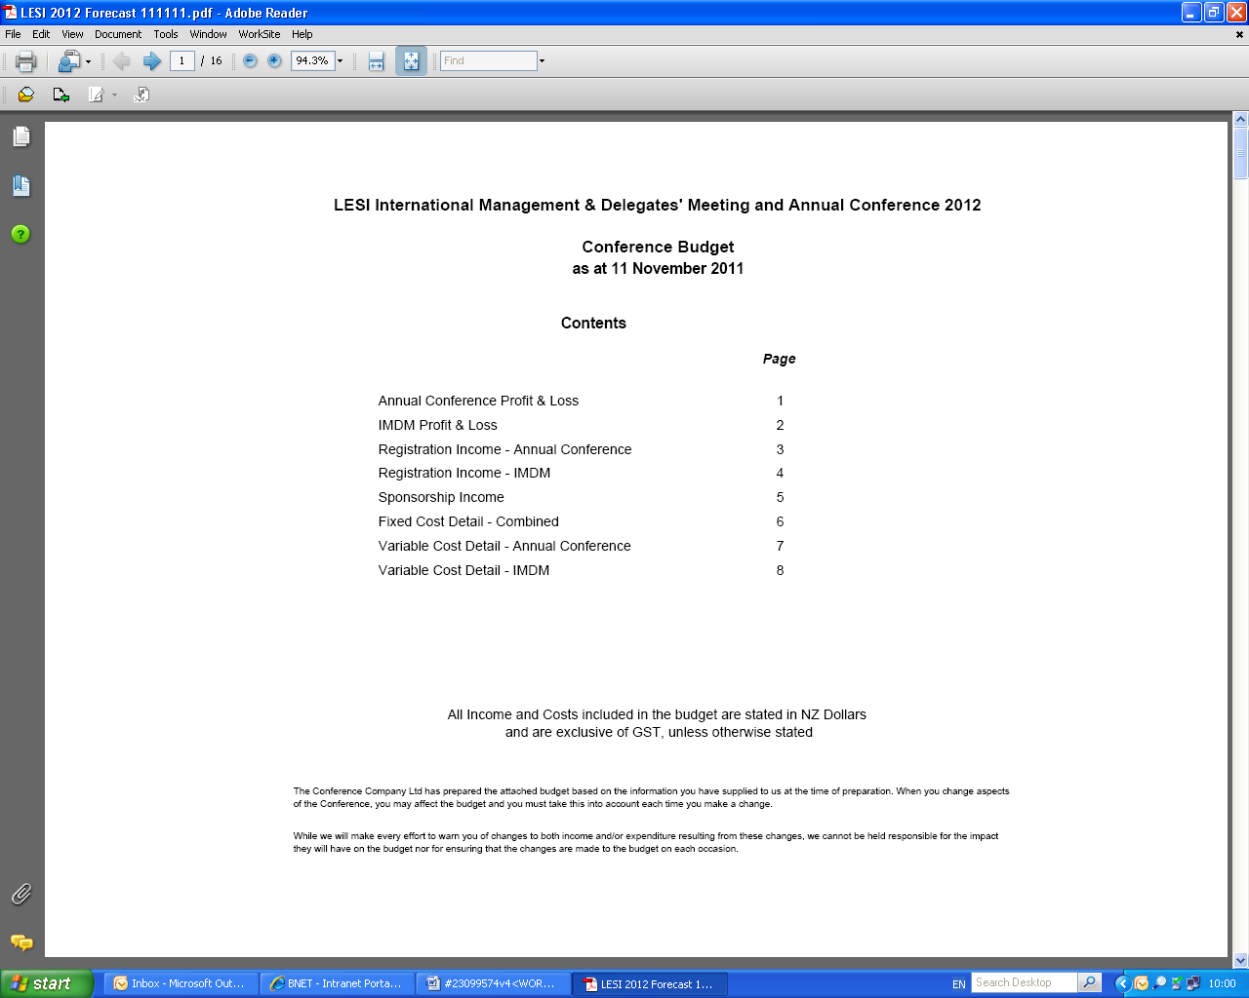

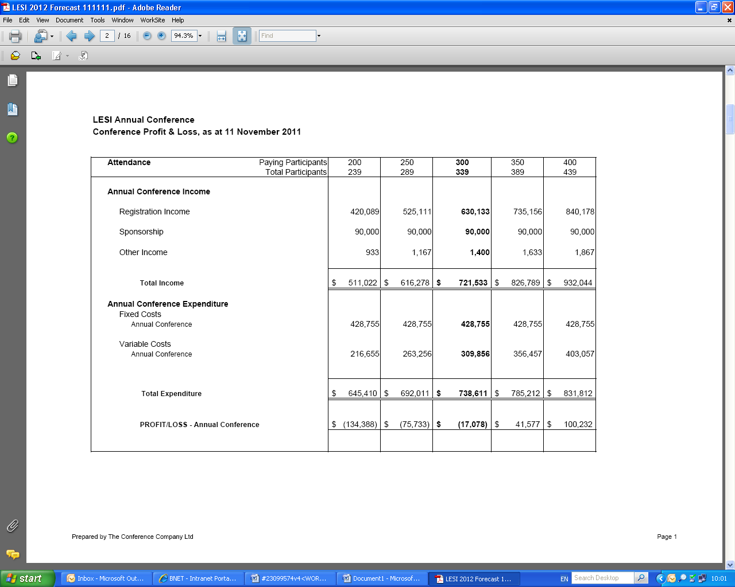

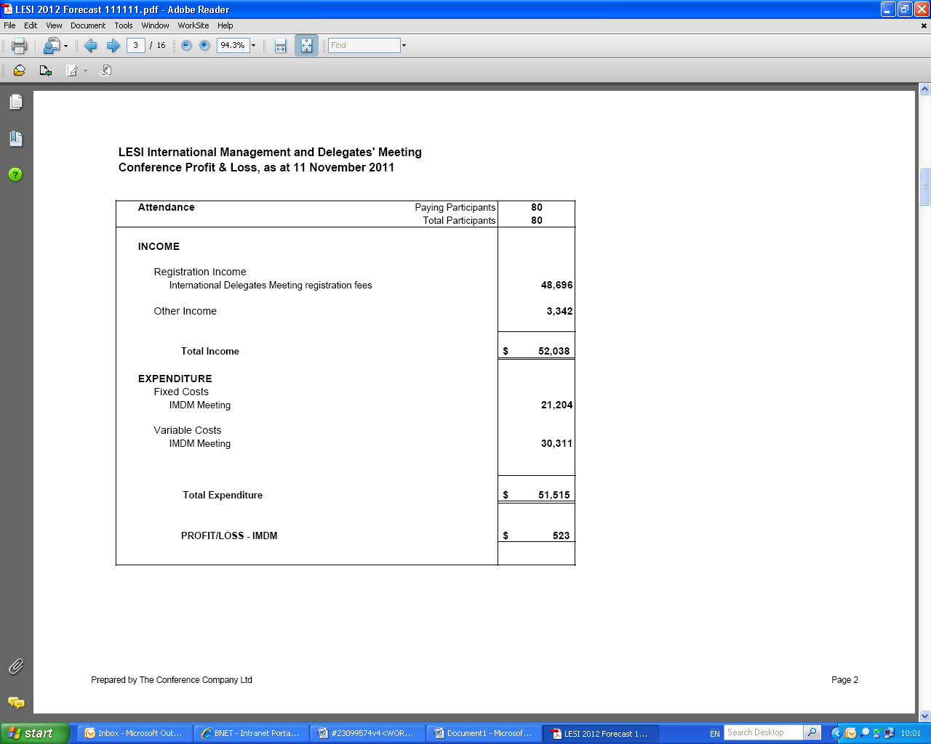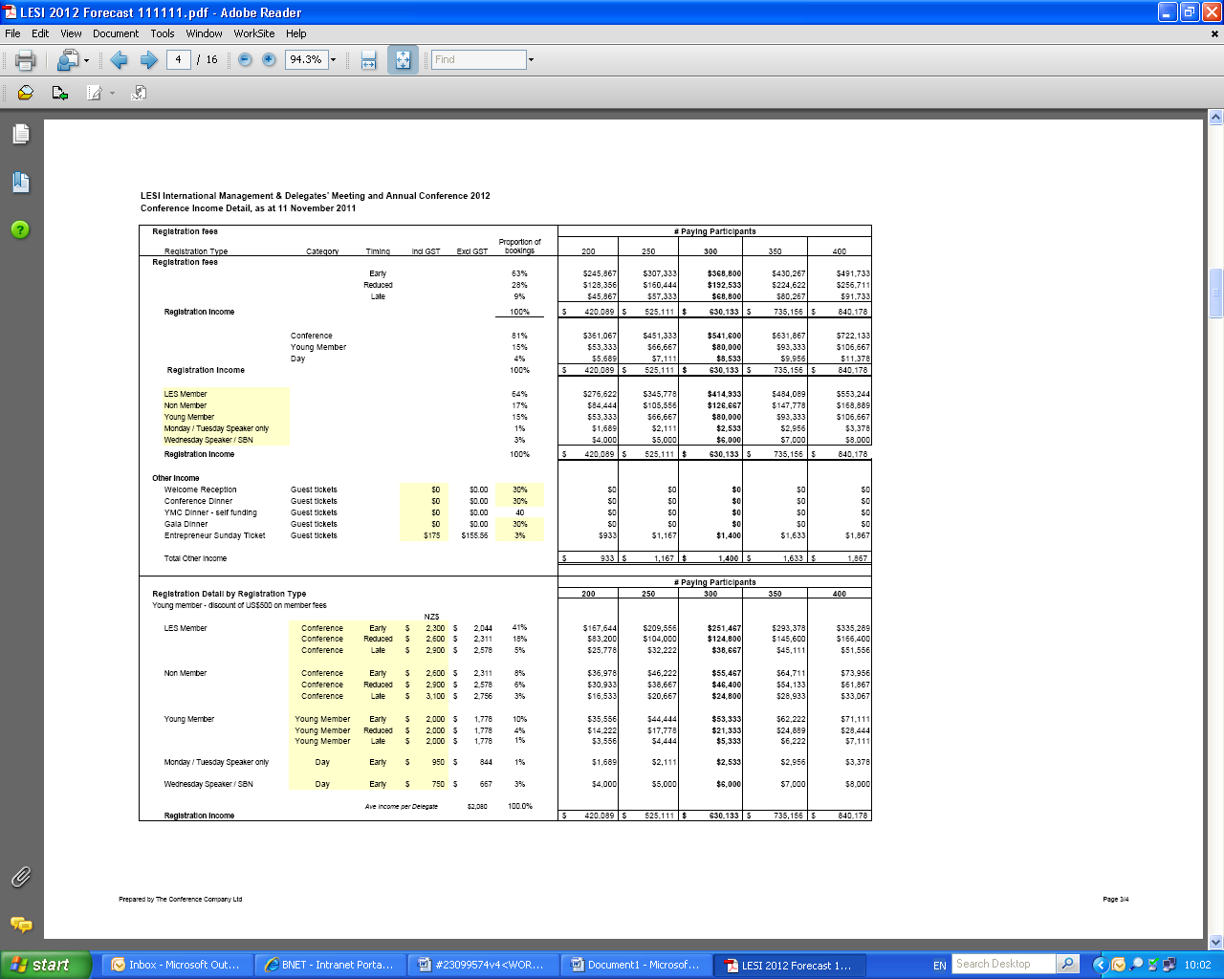

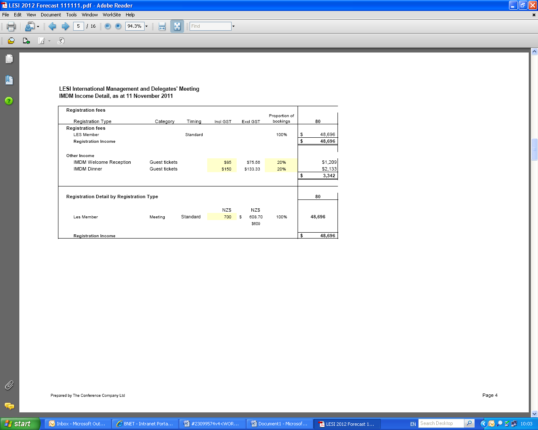

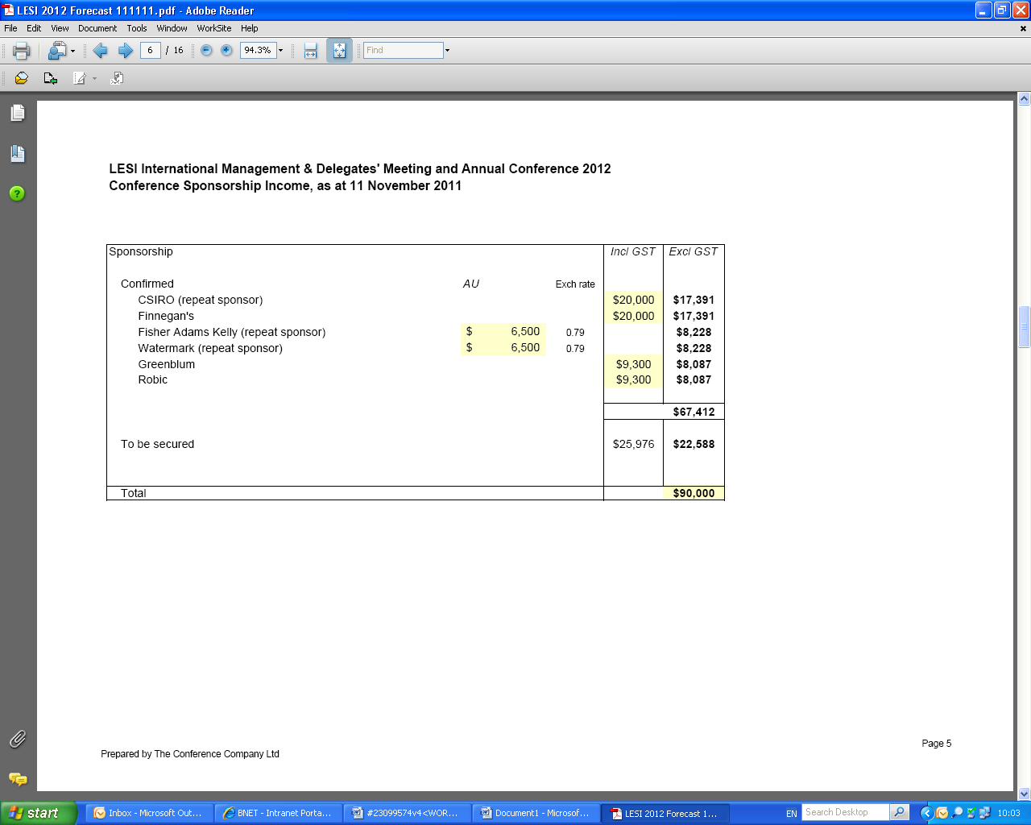

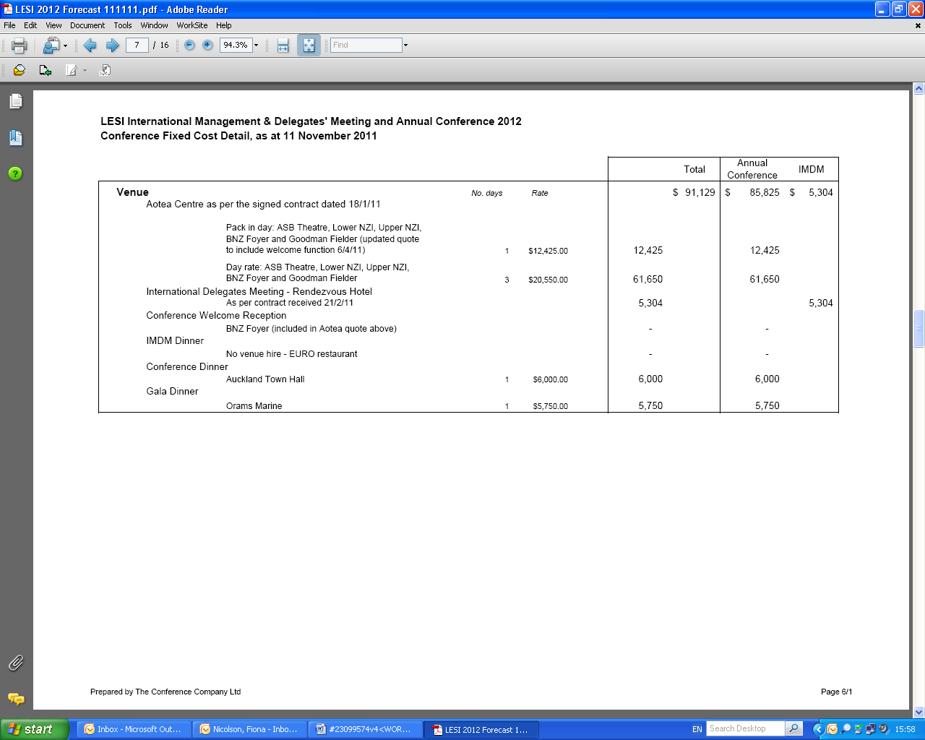

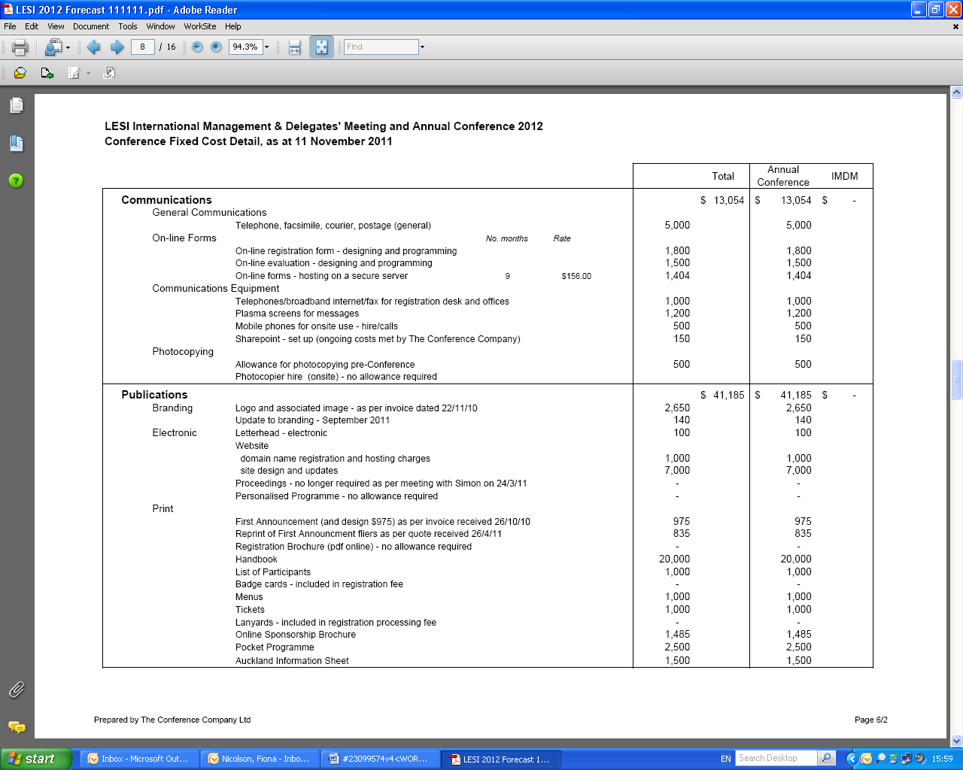

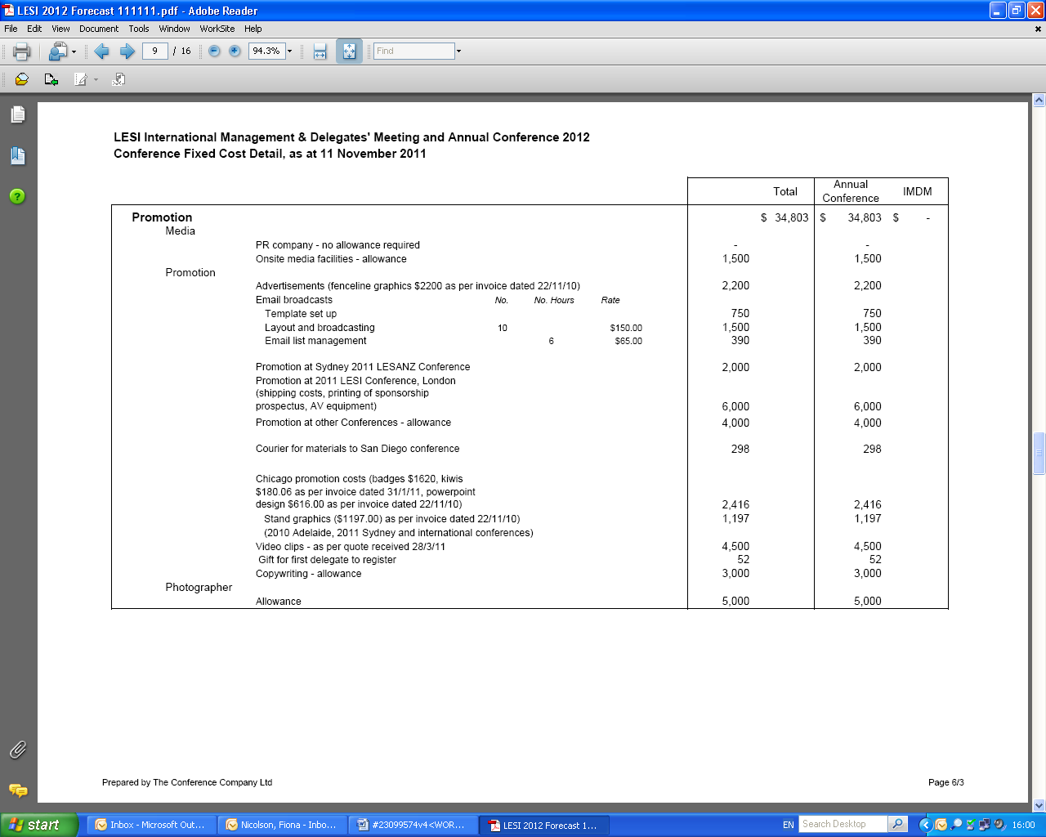

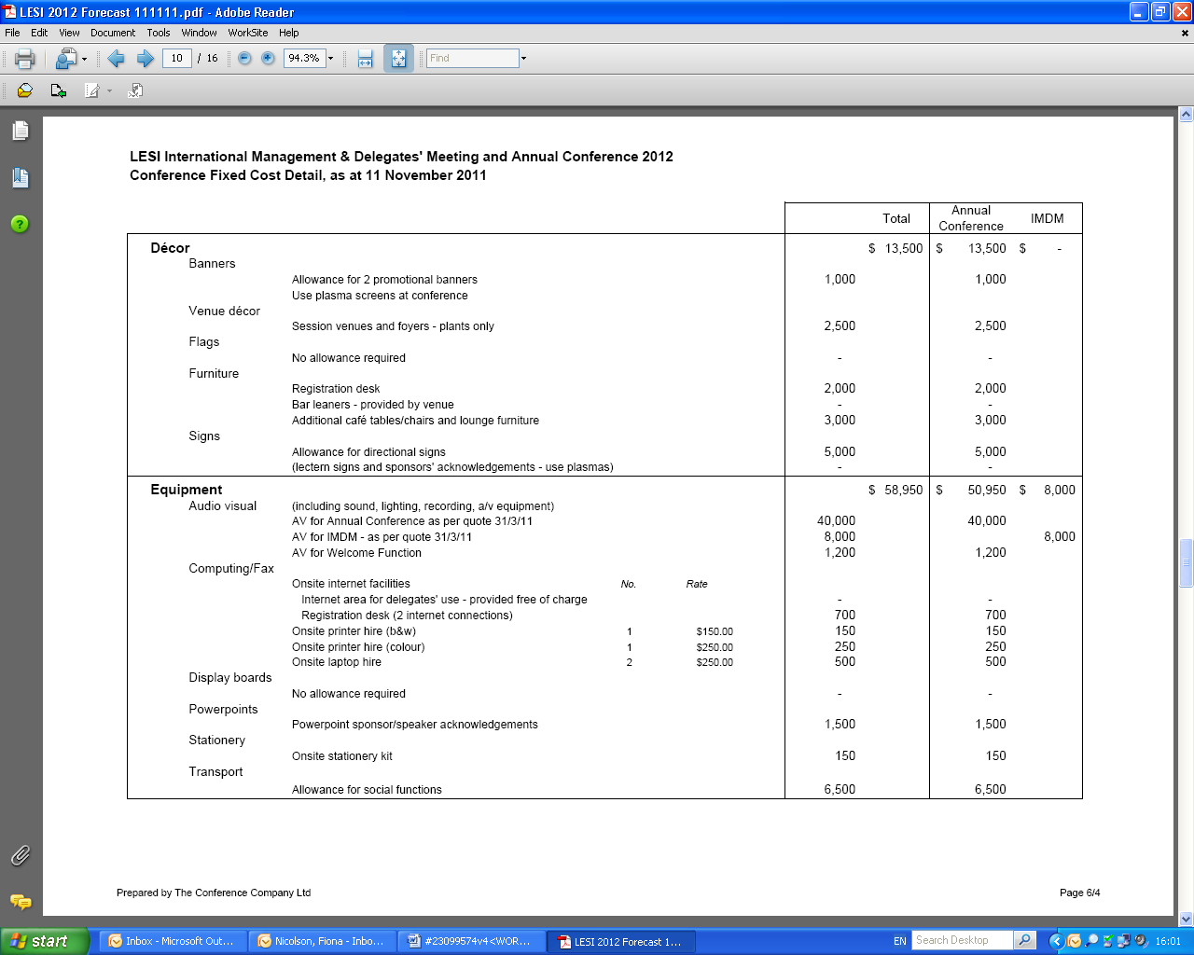

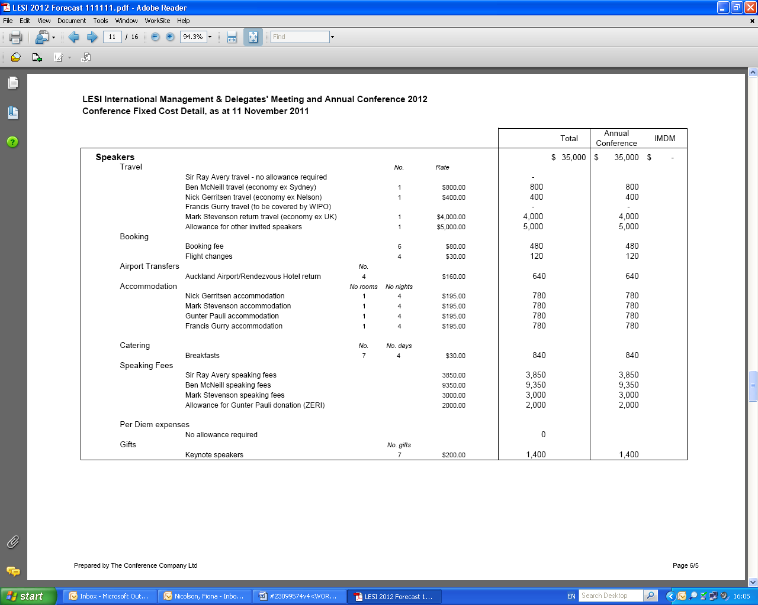

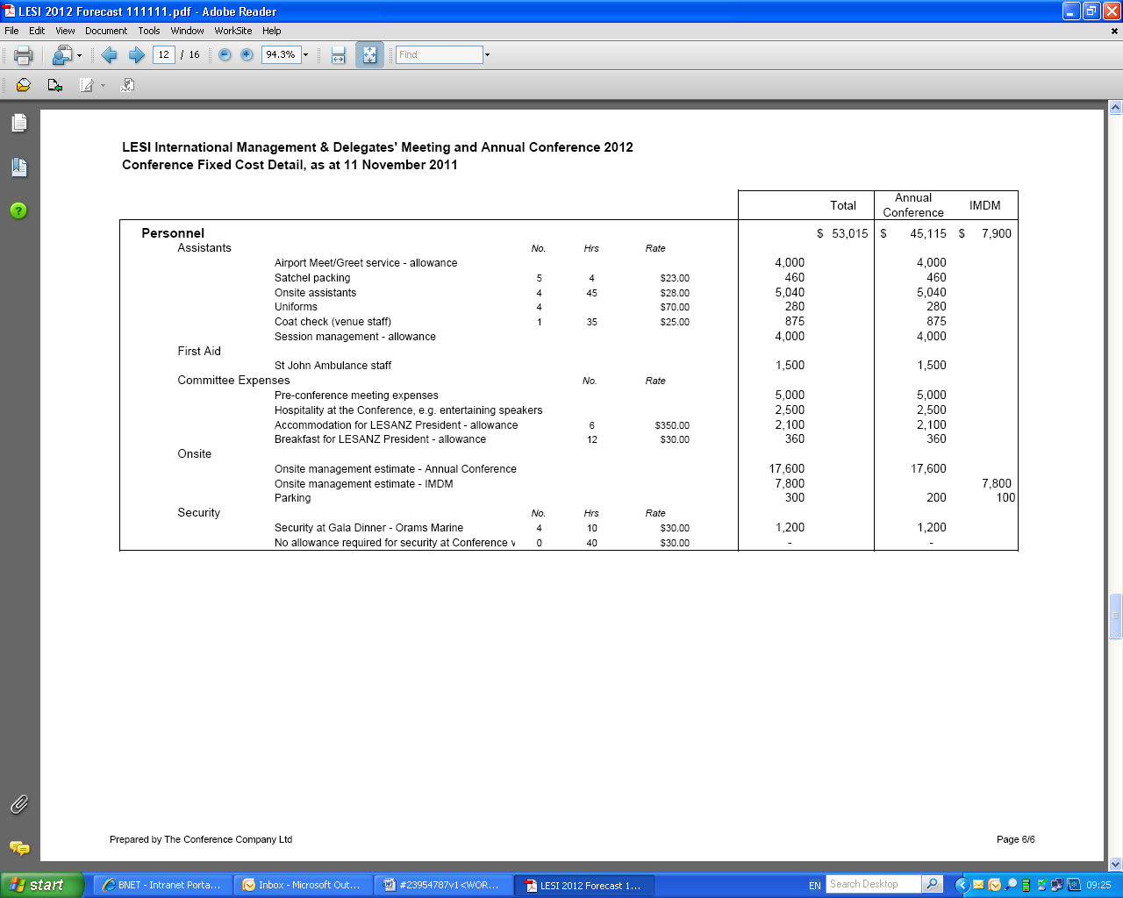

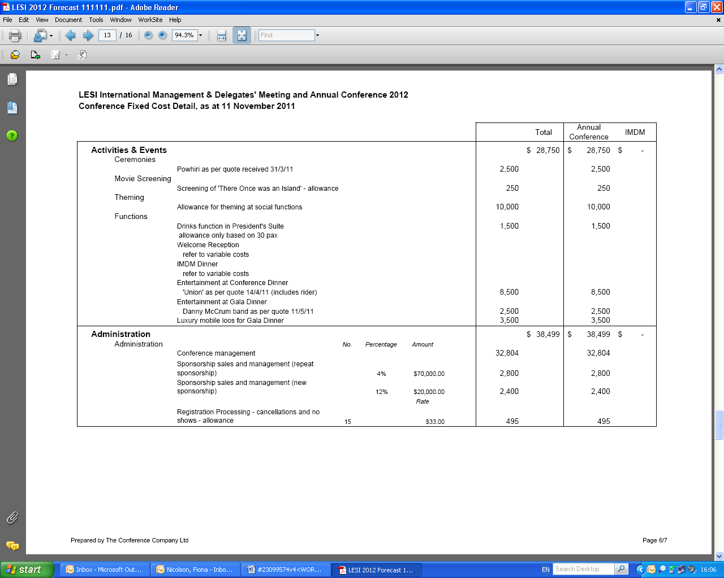

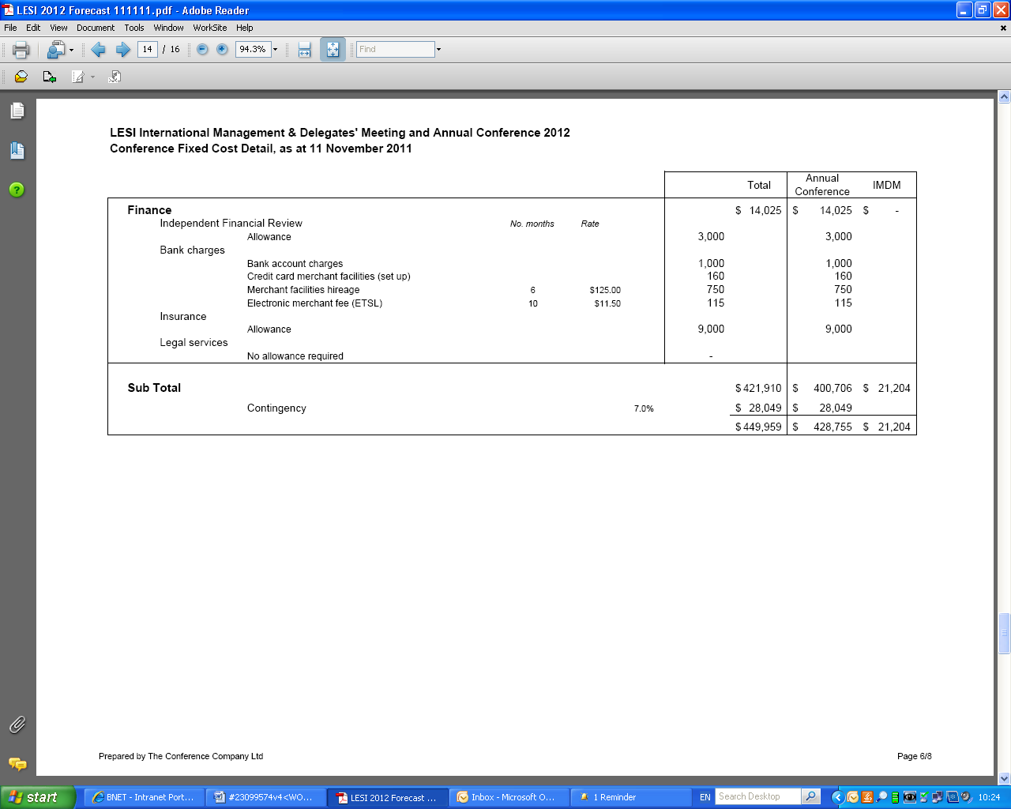

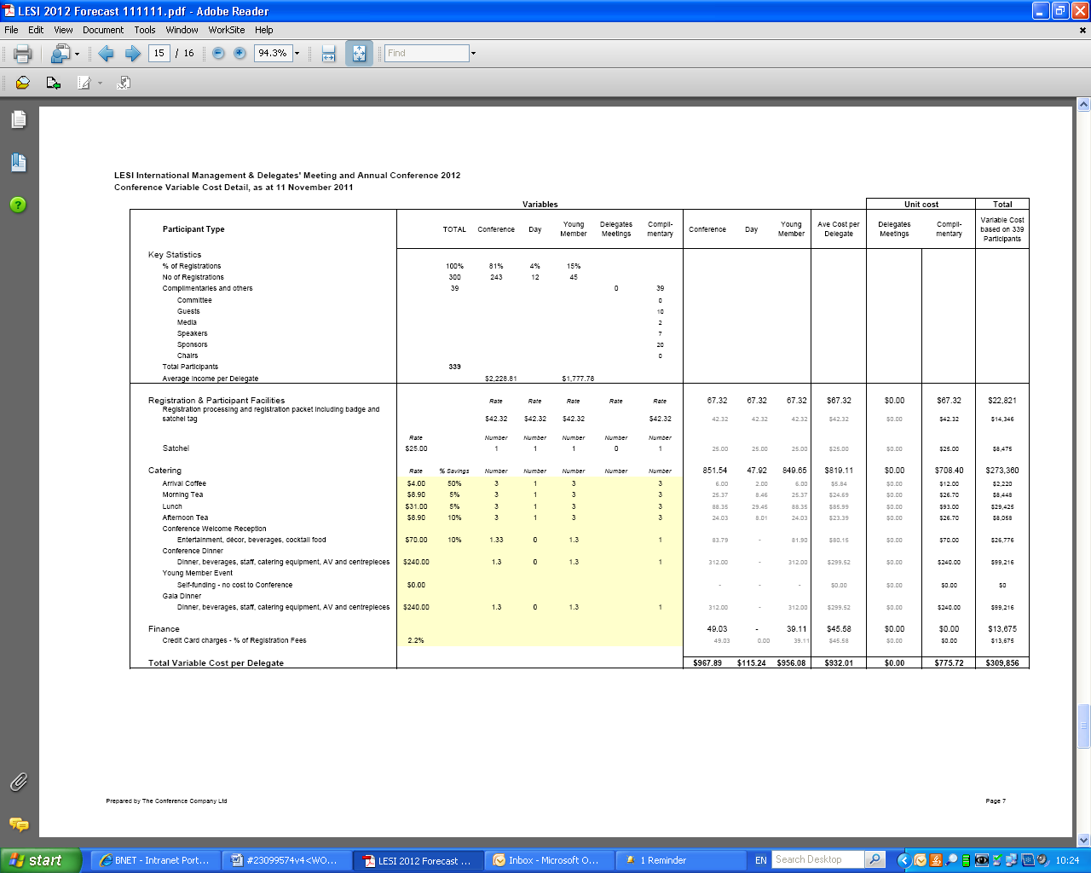

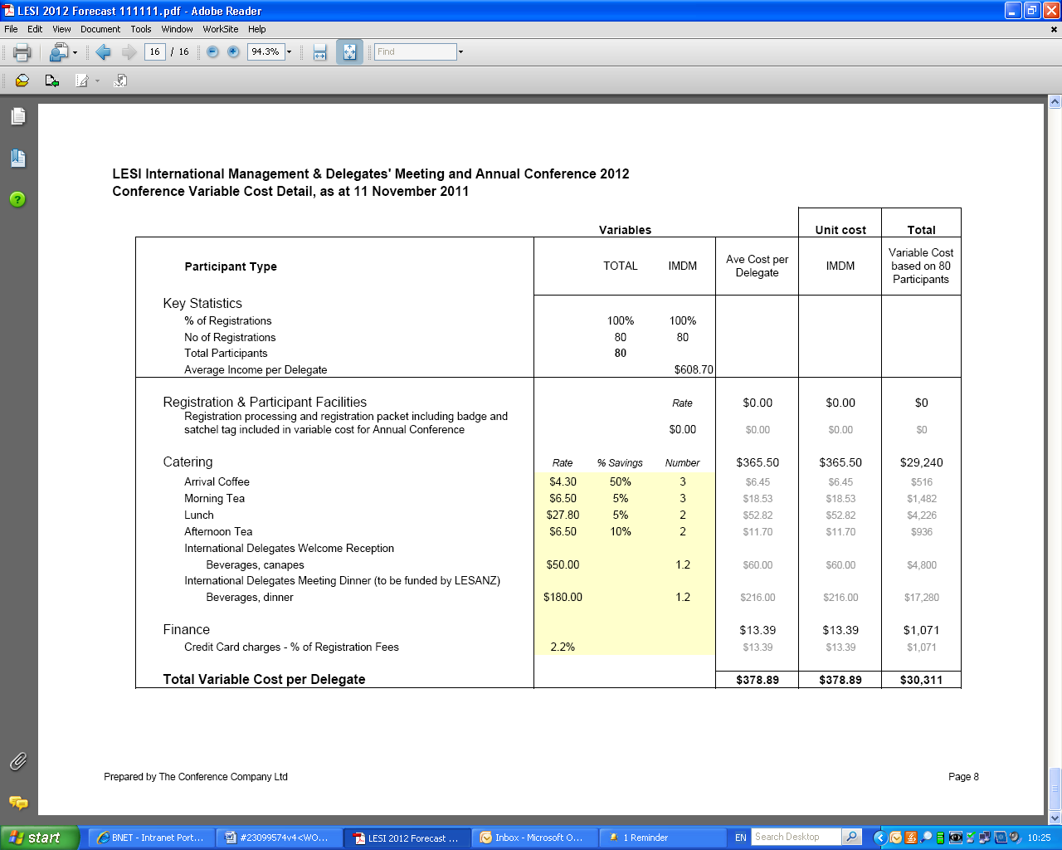

ANNEX 6

CONTRACT WITH HOST SOCIETY

This Agreement is made between

<insert appropriate description of LESI association incorporated somewhere> (LESI)

and

<insert details of host society> (Host Society)

Whereas

LESI grants the Host Society the right to host the LESI Annual Meeting in <insert name of host city> in <insert year>.

Agreement

The Host Society agrees to host the Annual Meeting in accordance with the terms and conditions outlined herein.

The Host Society agrees to comply with the responsibilities set out in the LESI Meetings Manual. For avoidance of doubt, LESI and the Host Society agree that they have the following responsibilities. If there is any conflict between this agreement and the Meetings Manual, this agreement prevails.

Host Society Responsibilities

The Host Society will:

* Comply with the timeline attached as Annex 1;
* Select an Organising Committee and submit the names of the members of the Organising Committee to LESI Meetings Committee for approval;
* Prepare a budget for the Annual Meeting and submit the budget for approval;
* Identify a Professional Conference Organiser, negotiate a contract with the Professional Conference Organiser and submit the contract to LESI Meetings Committee for approval;
* Contract with the PCO upon receipt of approval from the LESI Meetings Committee;
* Identify a conference venue;
* Submit details of the conference venue to LESI Meetings Committee for approval;
* Book the conference venue upon receipt of approval from LESI Meetings Committee;
* Submit regular progress reports to LESI Meetings Committee at each International Management and Delegates Meeting.

LESI Responsibilities

LESI will:

* Provide a loan of <insert amount> on the terms outlined in section XIV A of the Meetings Manual ;
* Actively promote the Annual Meeting at all LESI meetings;
* Advertise the Annual Meeting in Les Nouvelle;
* Advise the Organising Committee of all ancillary requirements for the Annual Meeting including:
  + The number of attendees, preferred date and preferred menu for any board dinners to be held during the conference;
  + The expected number of delegates, room requirements and function requirements for the International Management and Delegates Meeting held in conjunction with the Annual Meeting;
* Provide the following services referred to in section XIV B of the Meetings Manual;
  + <insert agreed list of services>

Financial Considerations

In consideration of hosting the Annual Meeting the Host Society shall be entitled to keep <insert percentage> of any surplus and shall remit the remainder of the surplus to LESI within <?> days of submitting finalised audited conference accounts to LESI Meetings Committee.

Dispute Resolution

In the event of any dispute arising between LESI and the Host Society in relation to the conduct of the Annual Meeting, the parties agree to use their best endeavours to resolve the dispute by negotiation in good faith. Either party may give notice at any time that they desire determination of the dispute by the International Management and Delegates Meeting and the matter will be set down for discussion and resolution at the next International Management and Delegates Meeting.

LESI and the Host Society agree to be bound by the decision of the International Management and Delegates Meeting without recourse.

Termination

The Host Society may give notice at any time that they are unable to host the Annual Meeting unless but not until and unless the Organising Committee has consulted with the LESI Board of Directors and the Meetings Committee to see if any issues of concern can be addressed.

LESI may withdraw or defer the right of the Host Society to host the Annual Meeting if, and only if:

* LESI gives clear notice of the reasons for withdrawal of the right and the Host Society does not satisfactorily address the reasons within 3 months, the reasons being one or more of:
  + Dissolution or changes in the Organising Committee;
  + Financial incapacity of the Host Society;
  + Significant deterring events in the host country (such as war, natural disaster or political instability); or
  + Any other reason which in the view of LESI, acting reasonably, raises serious concern that the Annual Meeting will not proceed as planned,
* The Host Society breaches the terms of this agreement and fails to correct the breach within 3 months.

Jurisdiction

This agreement shall be governed by and construed under and in accordance with the laws of <insert country of host society>.

Signed for and on behalf of LESI by the International President

_______________________________ ___________________________

Name Secretary

Signed for and on behalf of <insert name of the Host Society> by the President

_______________________________ ___________________________

Name Secretary

ANNEX 7

METRICS FROM LESI AUCKLAND CONFERENCE (2012)

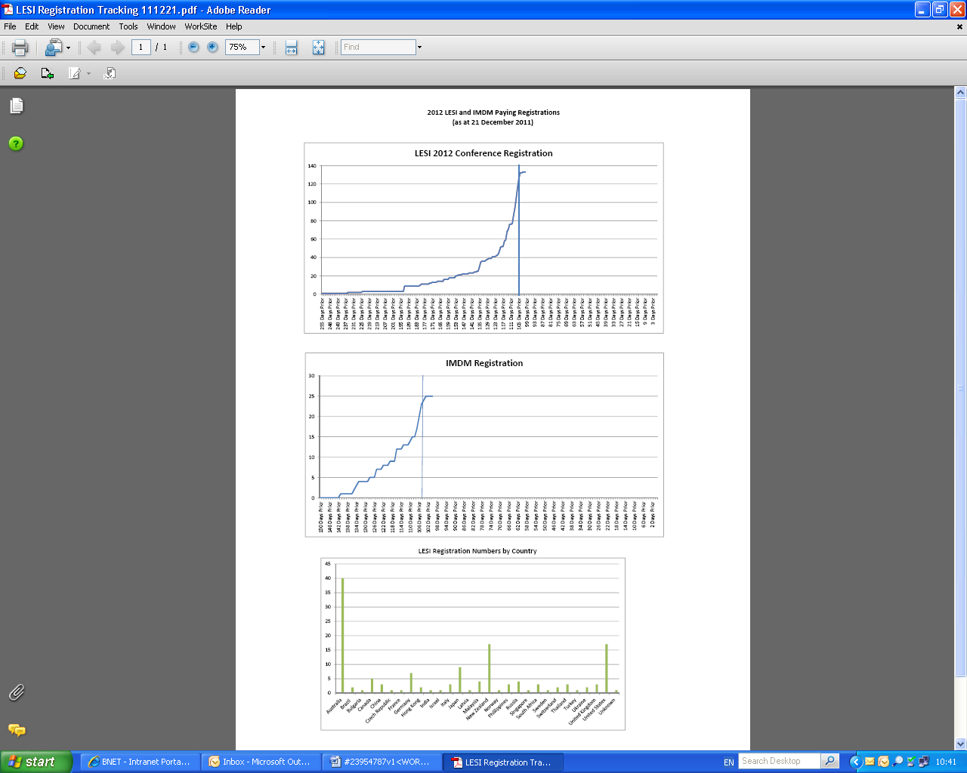**Metrics from previous conferences**